

***Information Systems Department***

***Second semester 1442/1443***



Raseel Alsaleh (442005360)

Reema Alshalhoub (442000618)

Reem Alghamd (442003525)

Atheer Almuzel (442002746)

*Online homemade Bakery*

INSTRUCTOR'S NAME: ms.ghada almodaifr

*MULTI-TIER APPLICATION DEVELOPMENT - IS234*

*Section 4i1*

Table of Contents:

# Introduction…………………………………………………………………….4

ER-Diagram of the database………………………………………………...….5

Site map…………………………………………………………………………6

Screen all codes………...……………………………………………………7-23

Screen Database tables………….………………………………….……….24-26

Screen user interface…….…………………………………………….……27-36

Table of figure:

Figure 1-ERD 5

Figure 2-Site map 6

Figure 3- admin login1 7

Figure 4- Admin Page1 8

Figure 5- Admin Page2 8

Figure 6-admin update1 9

Figure 7-admin update2 9

Figure 8-check admin login 10

Figure 9-Admin logout 10

Figure 11- admin CSS1 11

Figure 12- admin CSS2 11

Figure 13- user login1 12

Figure 14- user login2 12

Figure 15-register1 13

Figure 16- register2 13

Figure 17 - HomePage1 14

Figure 18 - HomePage2 14

Figure 19 - HomePage3 15

Figure 20-shop 1 16

Figure 21-shop2 16

Figure 22- custom order1 17

Figure 23- custom order2 17

Figure 24- custom order3 18

Figure 25- custom order4 18

Figure 26-cart1 19

Figure 27-cart2 19

Figure 28- user logout 20

Figure 29- CSS1 21

Figure 30-CSS2 21

Figure 31-CSS3 22

Figure 32-CSS4 22

Figure 33-System database 23

Figure 34-Admin table 23

Figure 35-cart table 24

Figure 36-Product table 24

Figure 37-Users table 25

Figure 38- admin login 26

Figure 39- admin page 1 26

Figure 40- admin page 2 27

Figure 41- update page 27

Figure 42- user login page1 28

Figure 43- user login page2 28

Figure 44- home page 1 29

Figure 45- home page 2 29

Figure 46- home page 3 30

Figure 47- shop1 31

Figure 48-shop2 31

Figure 49-shop3 32

Figure 50 - custom order1 33

Figure 51- custom order2 33

Figure 52- FAQ1 34

Figure 53 - FAQ2 34

Figure 54- shopping cart 35

**Introduction**

Easy bakery is a small business that benefits homemade pastries, custom-made cakes, and more kinds of sweets, so our mission for this website is to make ordering sweets and pastries efficient and easy.

Every customer must create a new account to log into. They can start ordering or go through the shop page and add the item they want to their cart and the admin side. The administrator can do multiple things like update, edit, and Delete items.

**ER Diagram**

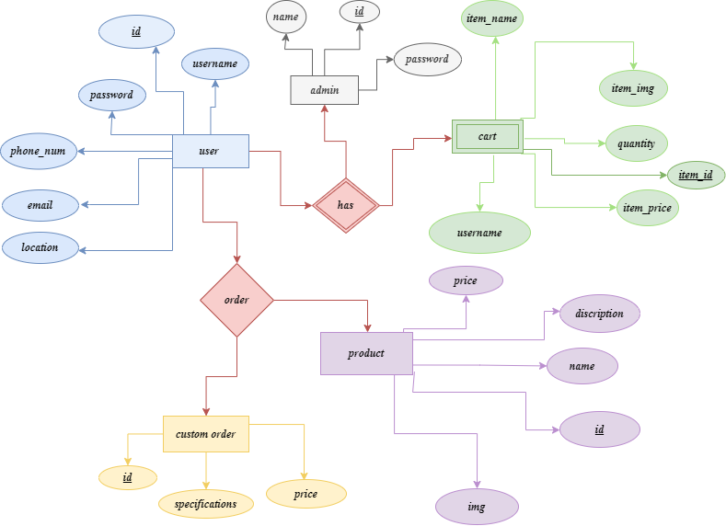

Figure 1-ERD

**Site map:**

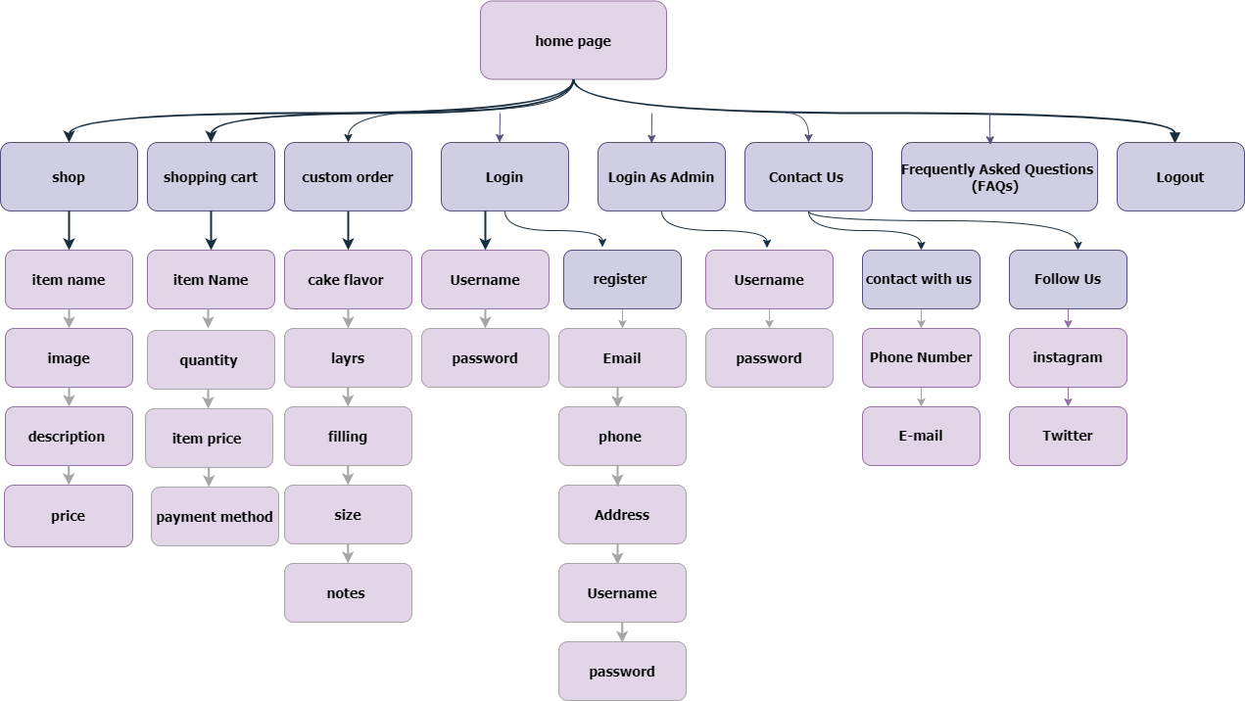

Figure 2-Site map

**Print screen of all codes:**

Admin login:

Figure 3- admin login1

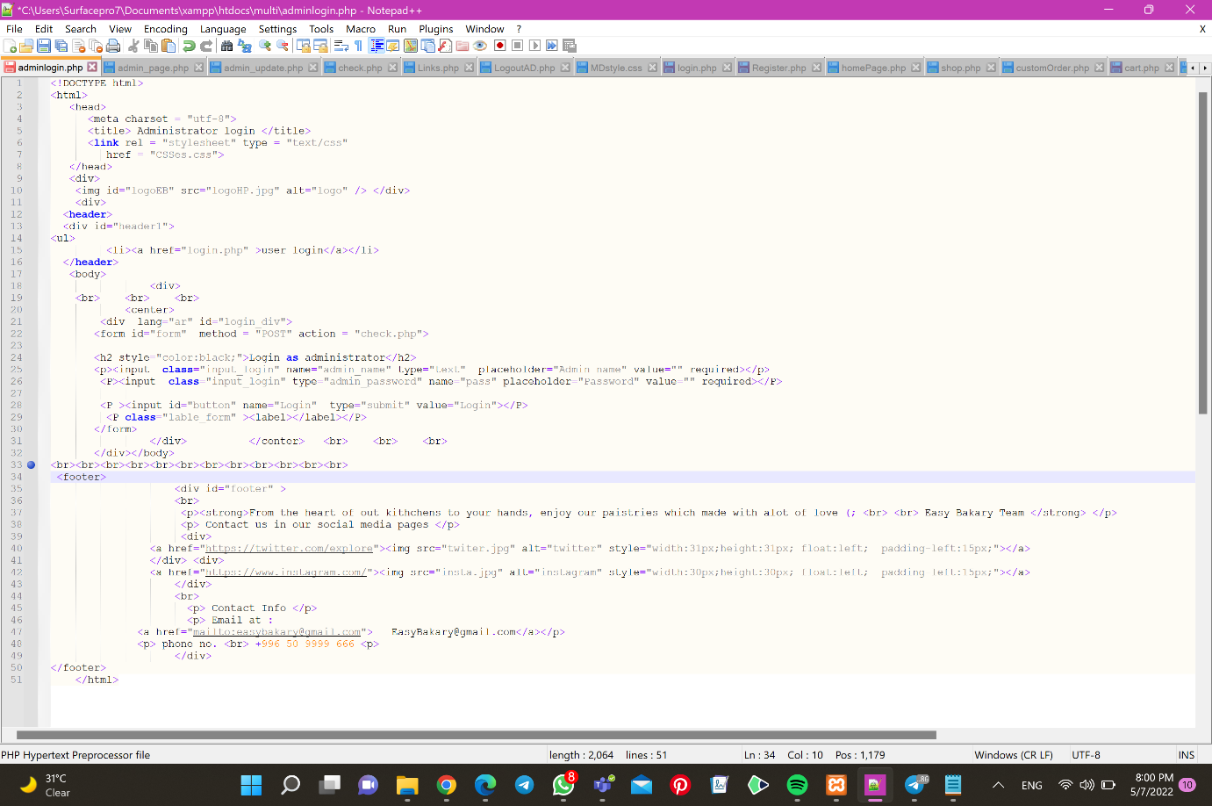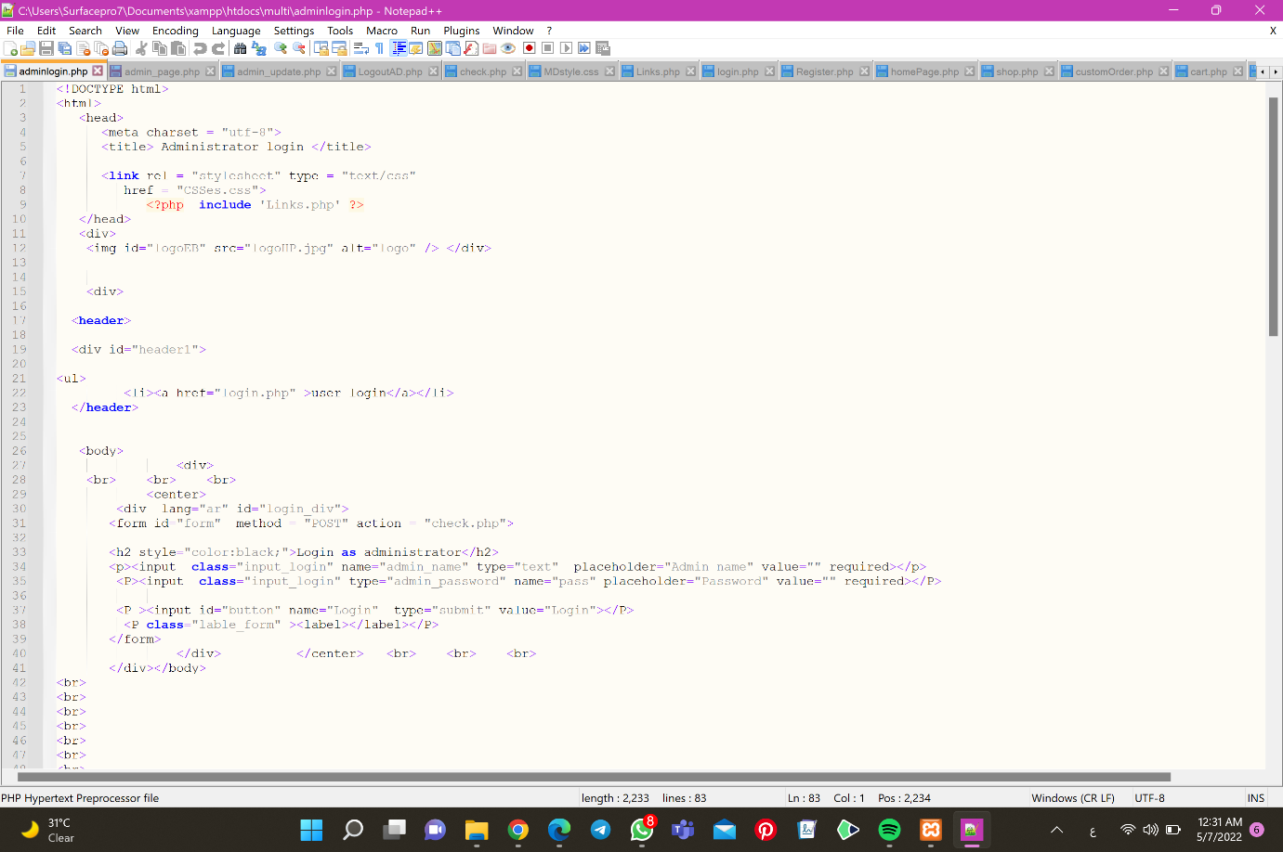

Admin page:

Figure 4- Admin Page1

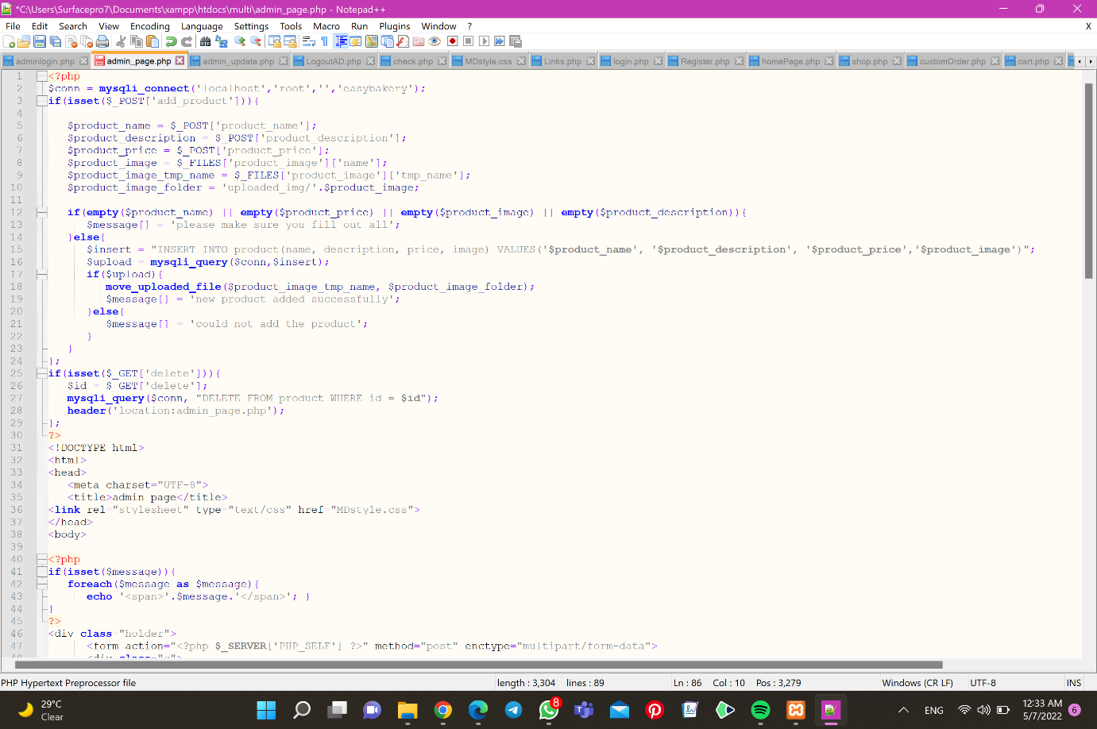

Figure 5- Admin Page2

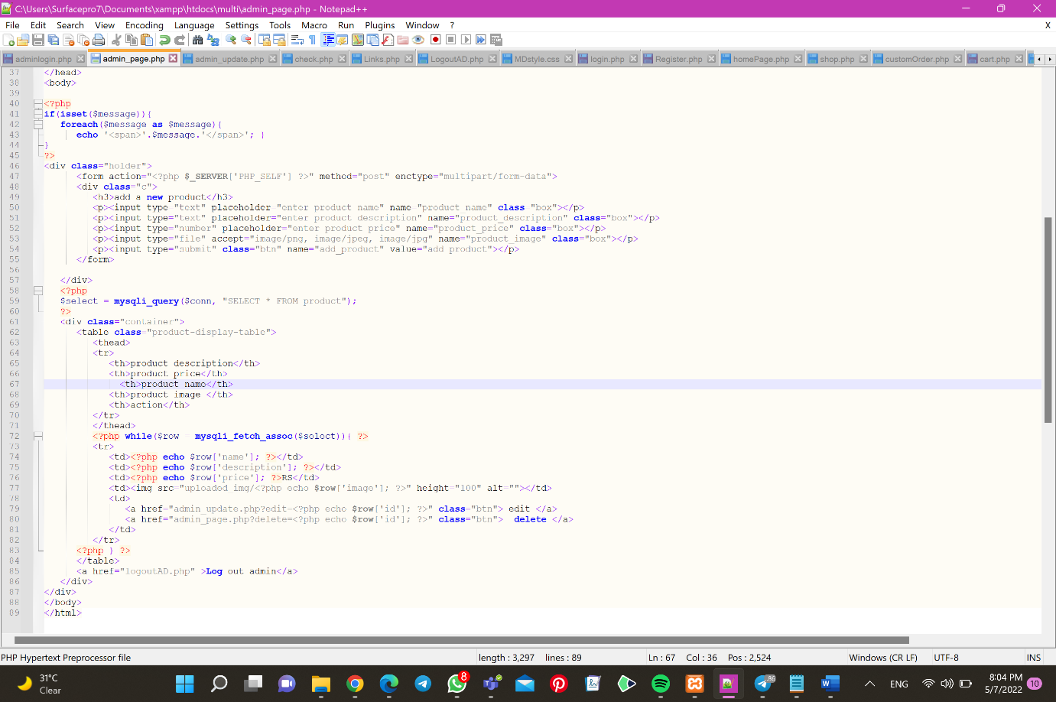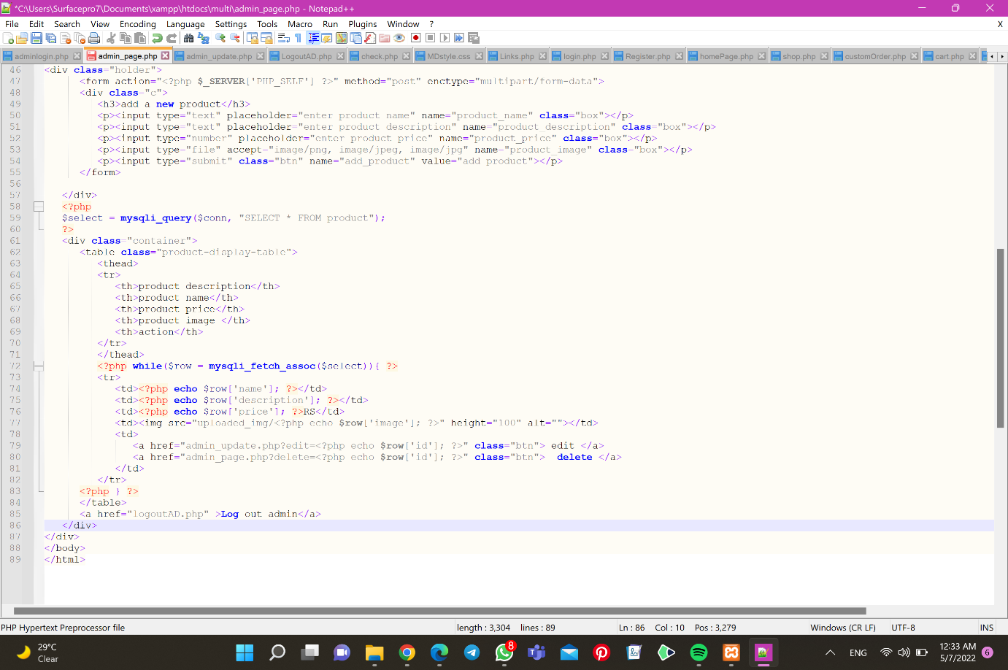

admin update:

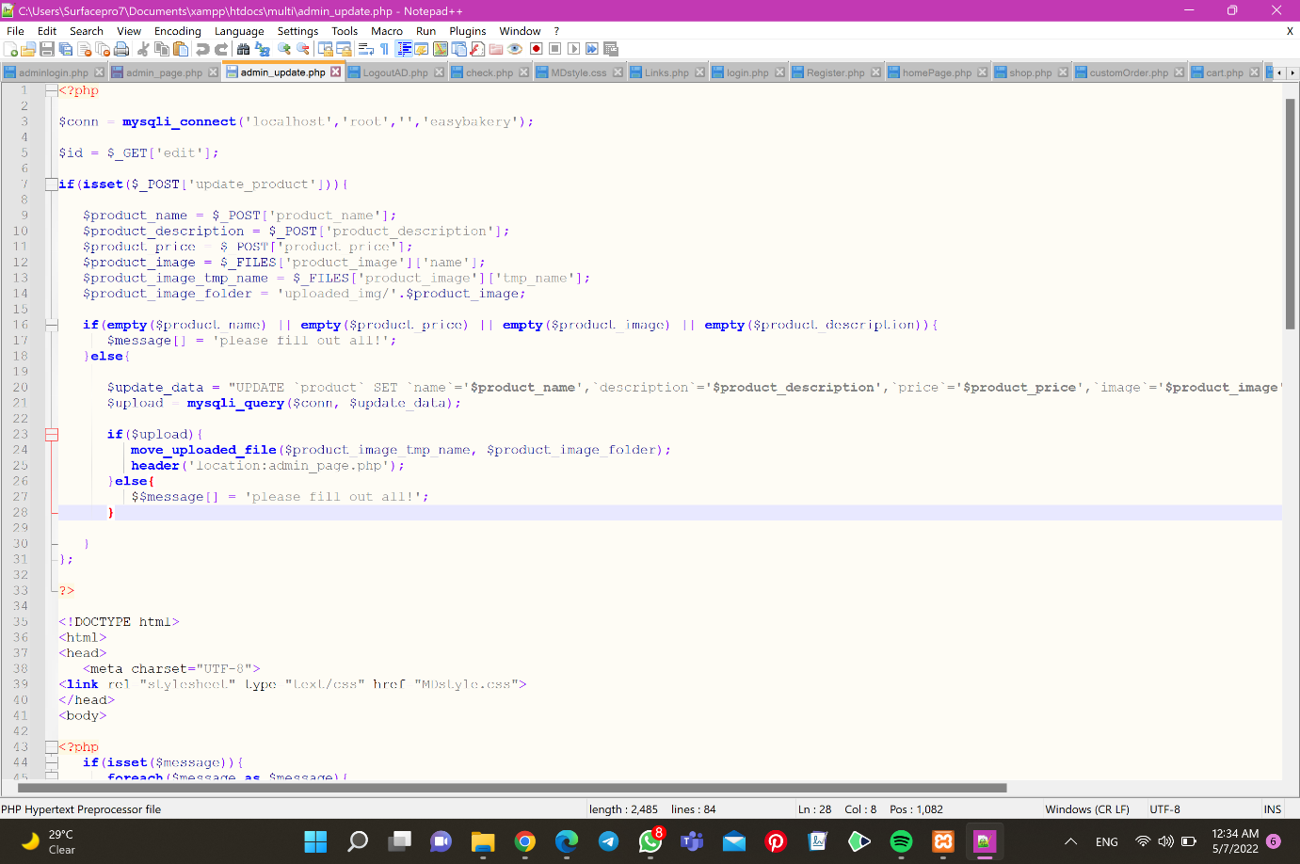

Figure 6-admin update1

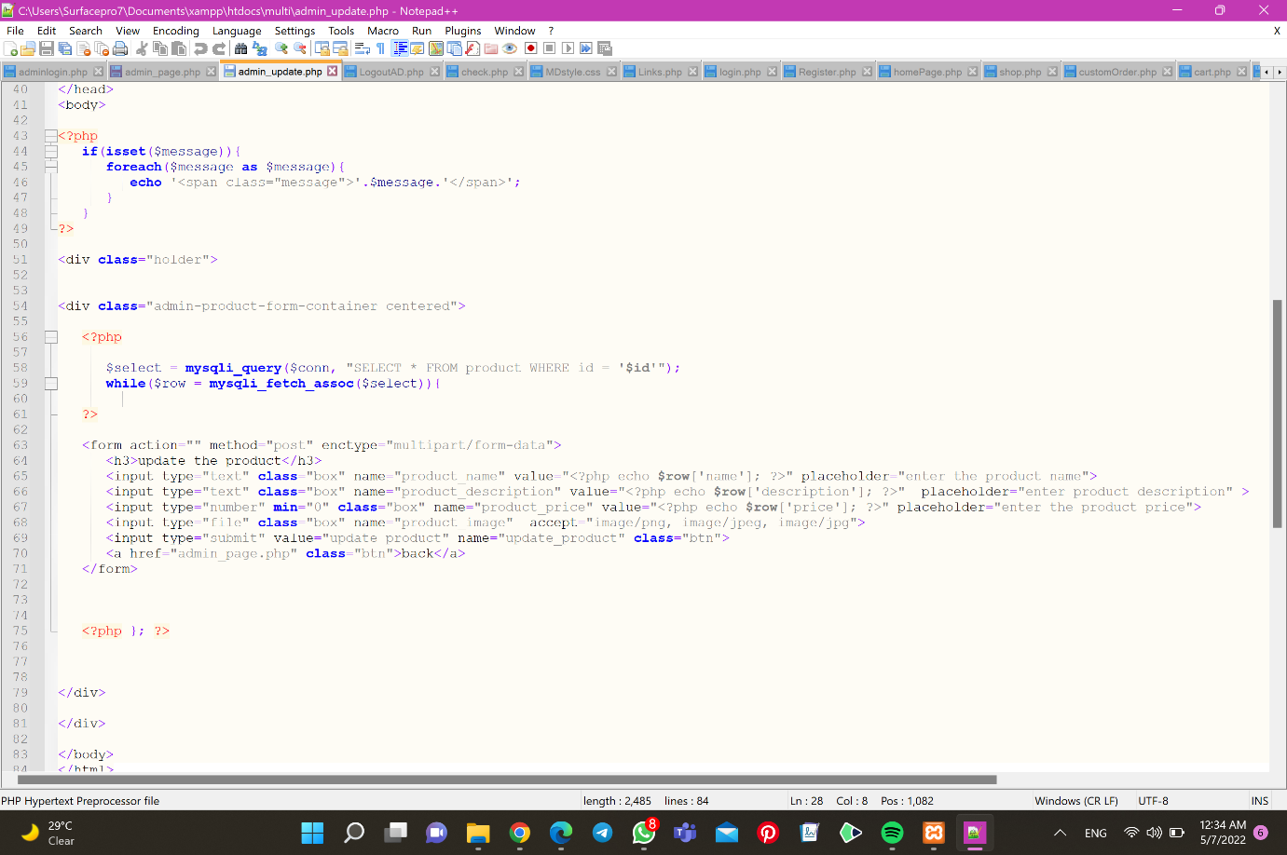

Figure 7-admin update2

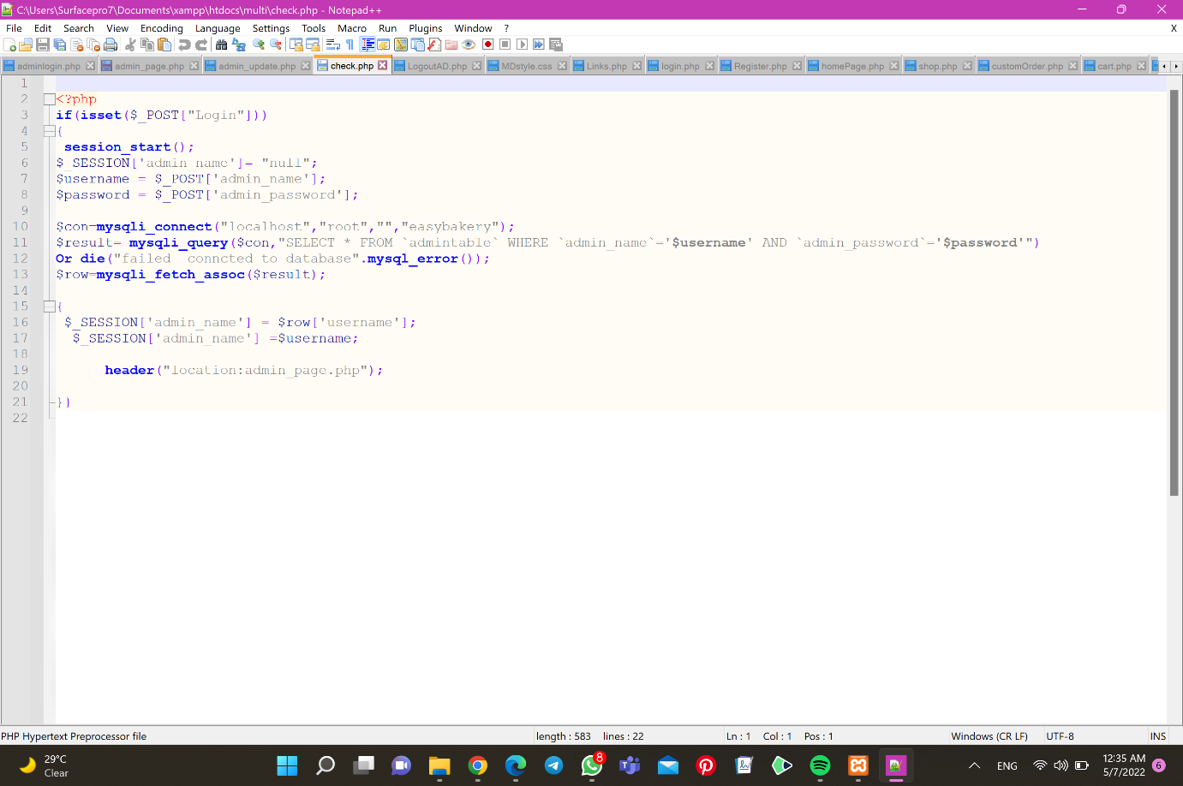check admin login:

Figure 8-check admin login

Admin logout:

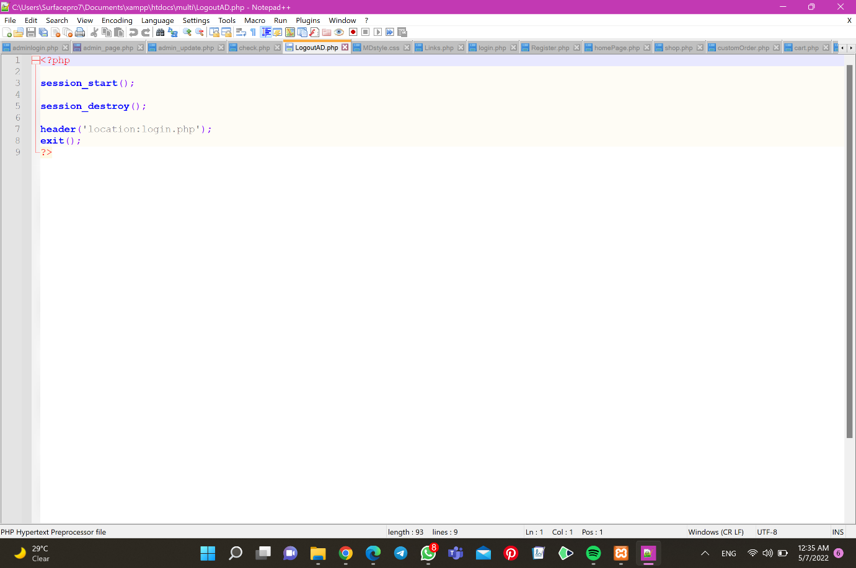

Figure 9-Admin logout

CSS admin:

Figure 10- admin CSS1

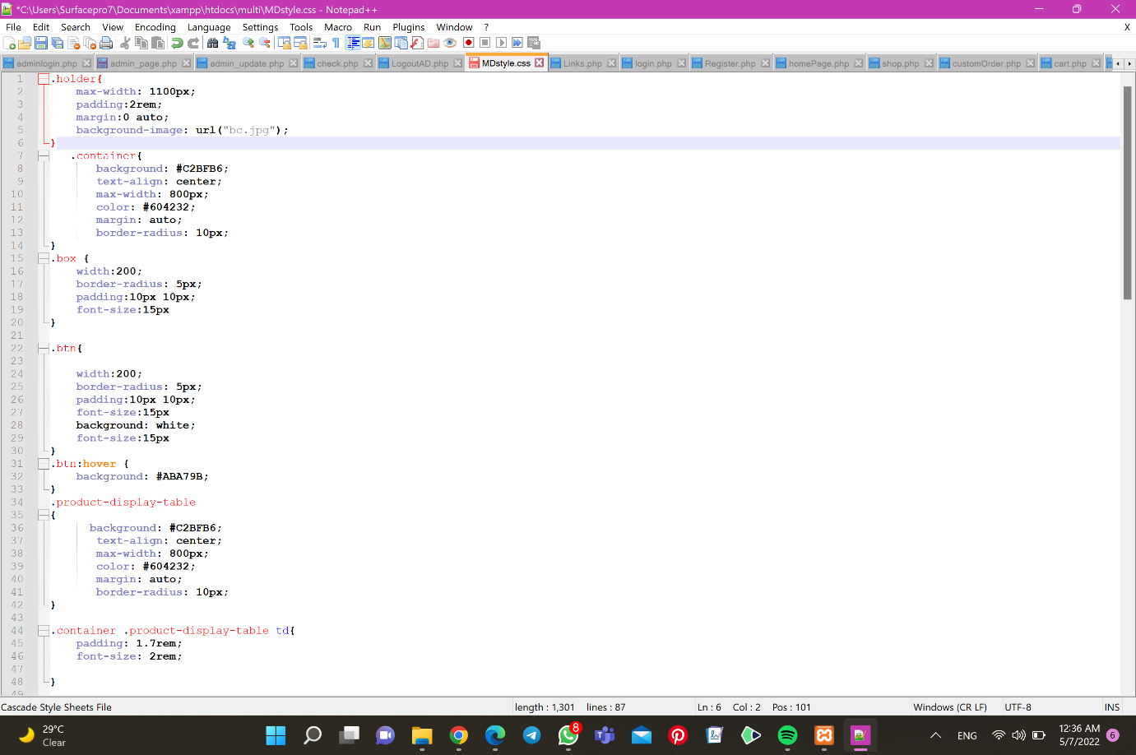

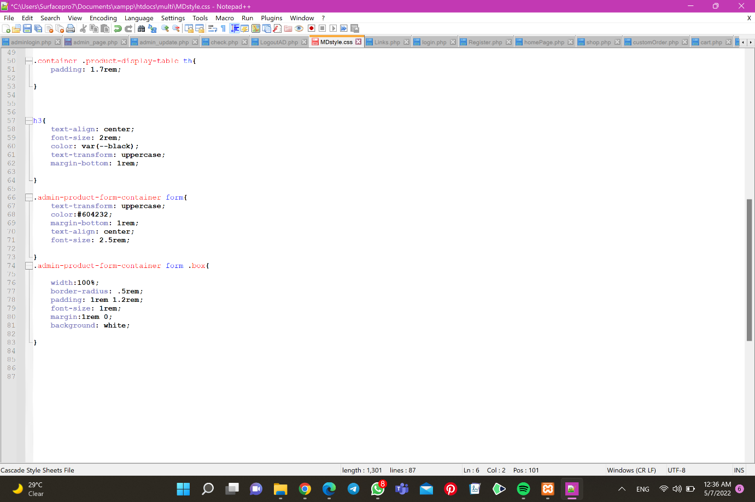

Figure 11- admin CSS2

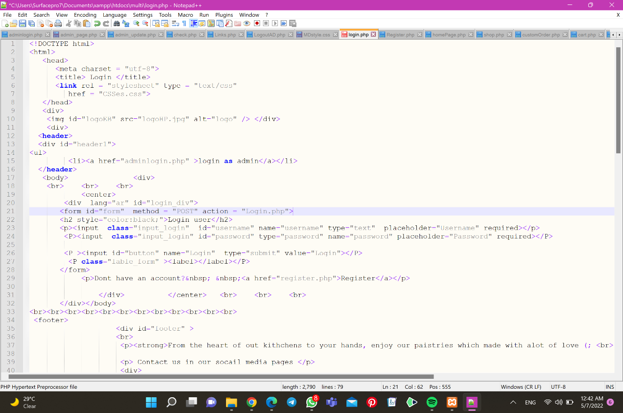User login:

Figure 12- user login1

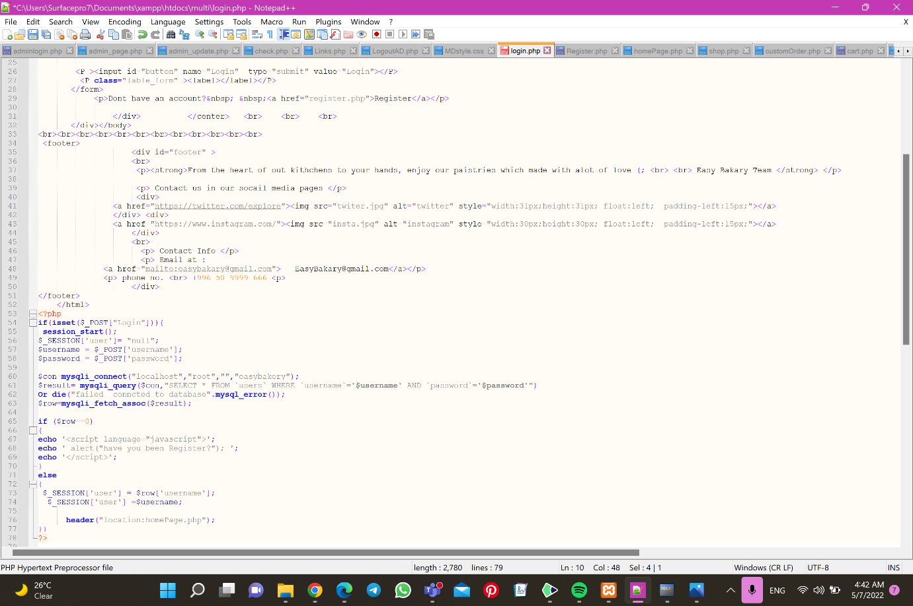

Figure 13- user login2

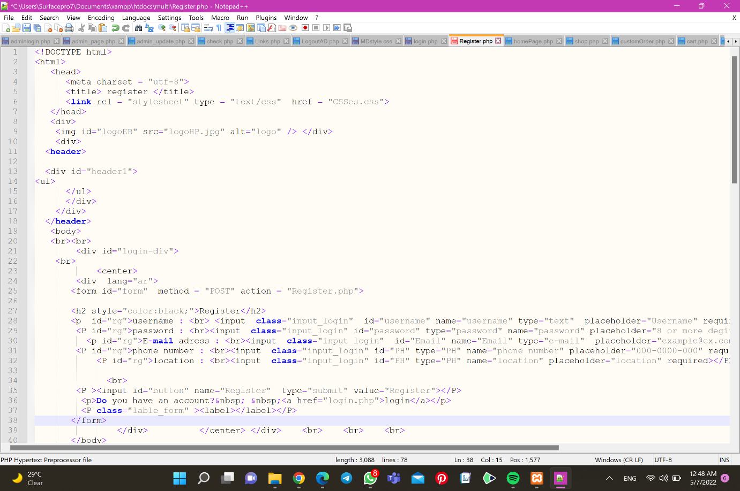Register

Figure 14-register1

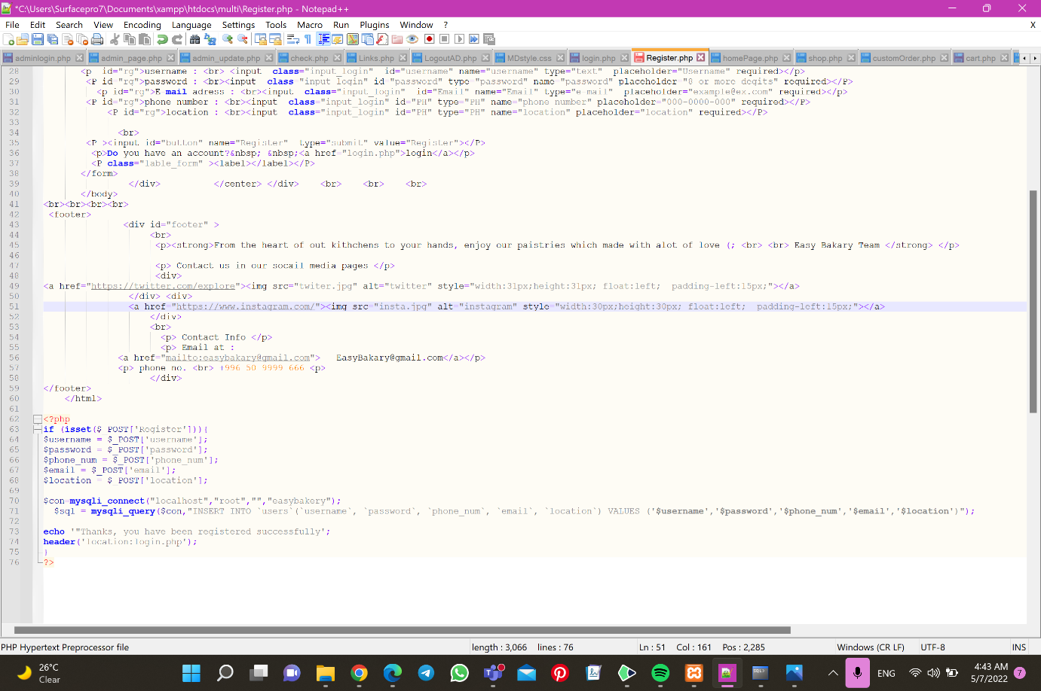

Figure 15- register2

Home page:

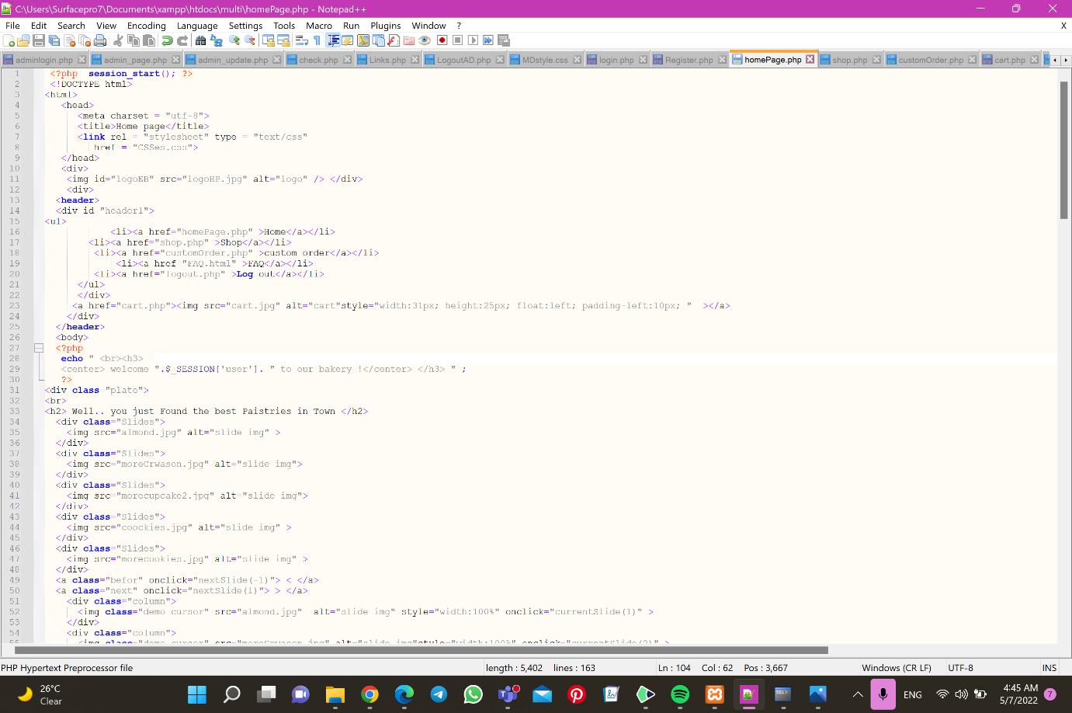

Figure 16 - HomePage1

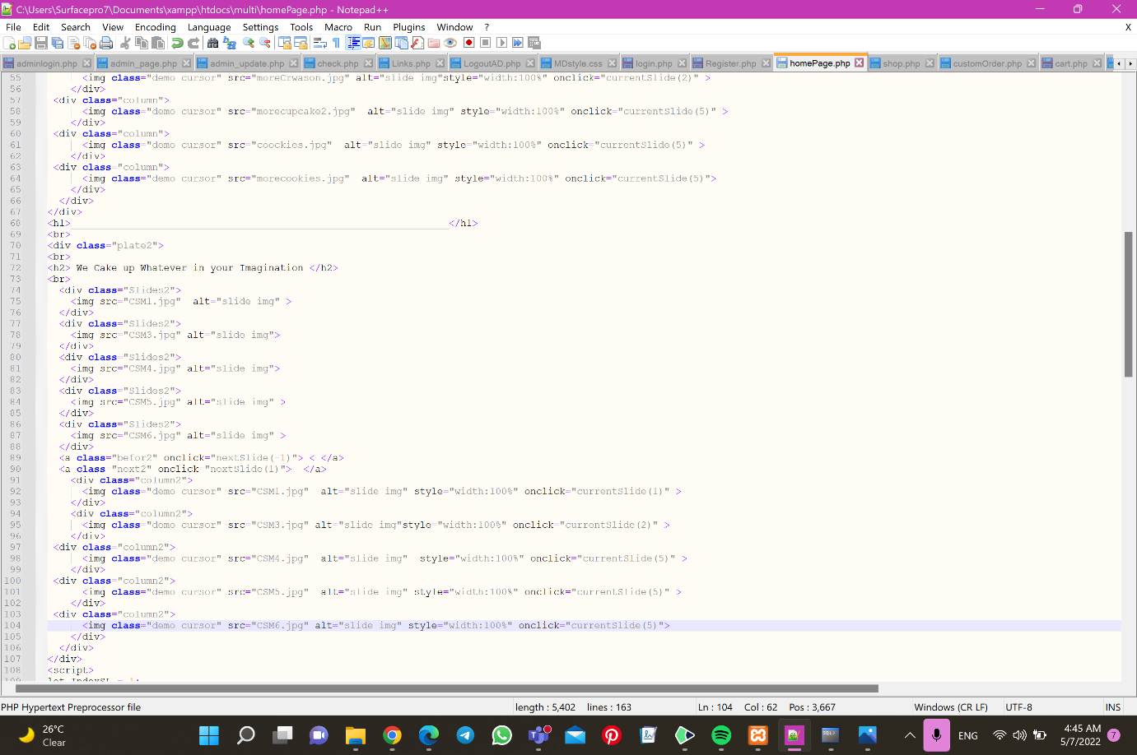

Figure 17 - HomePage2

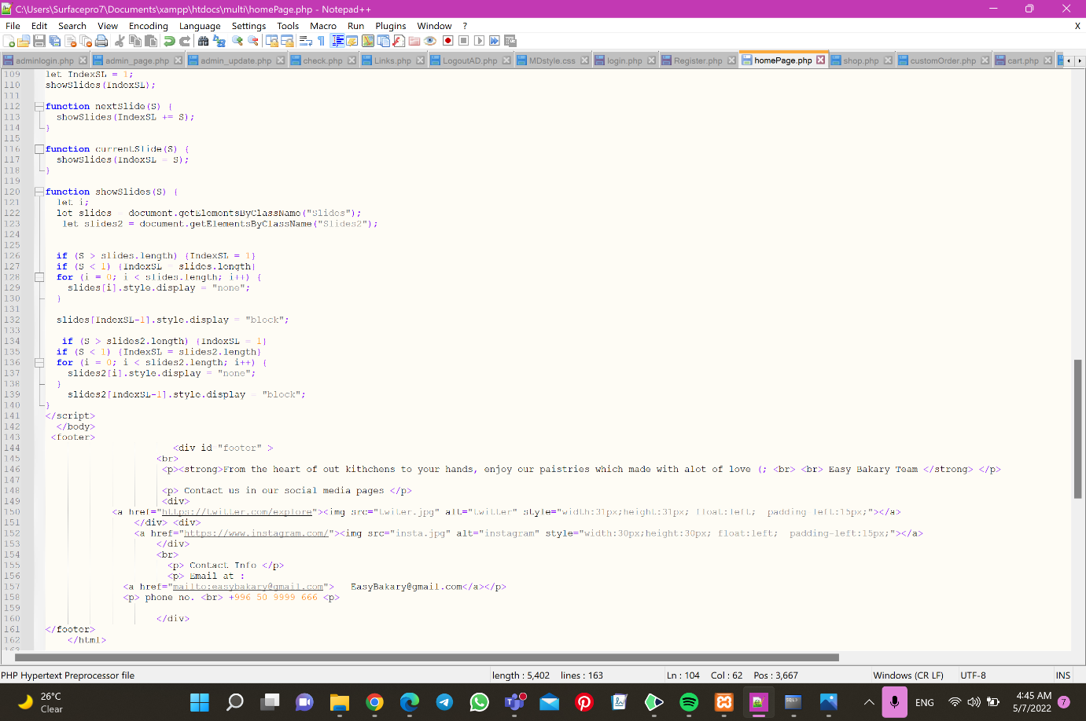

Figure 18 - HomePage3

Shop: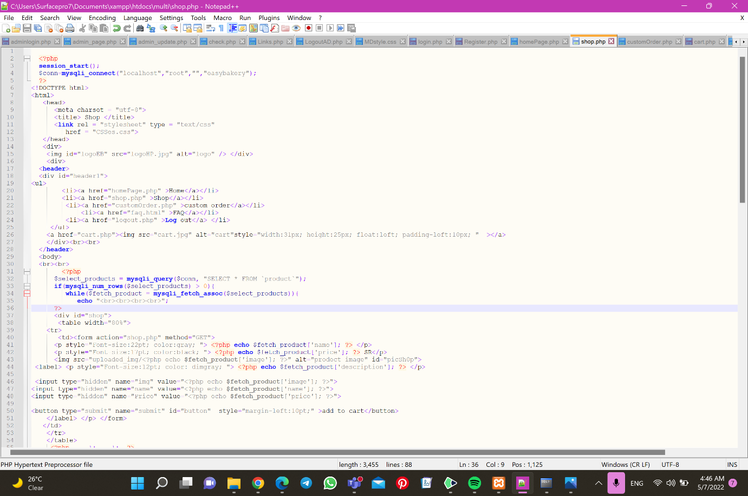

Figure 19-shop 1

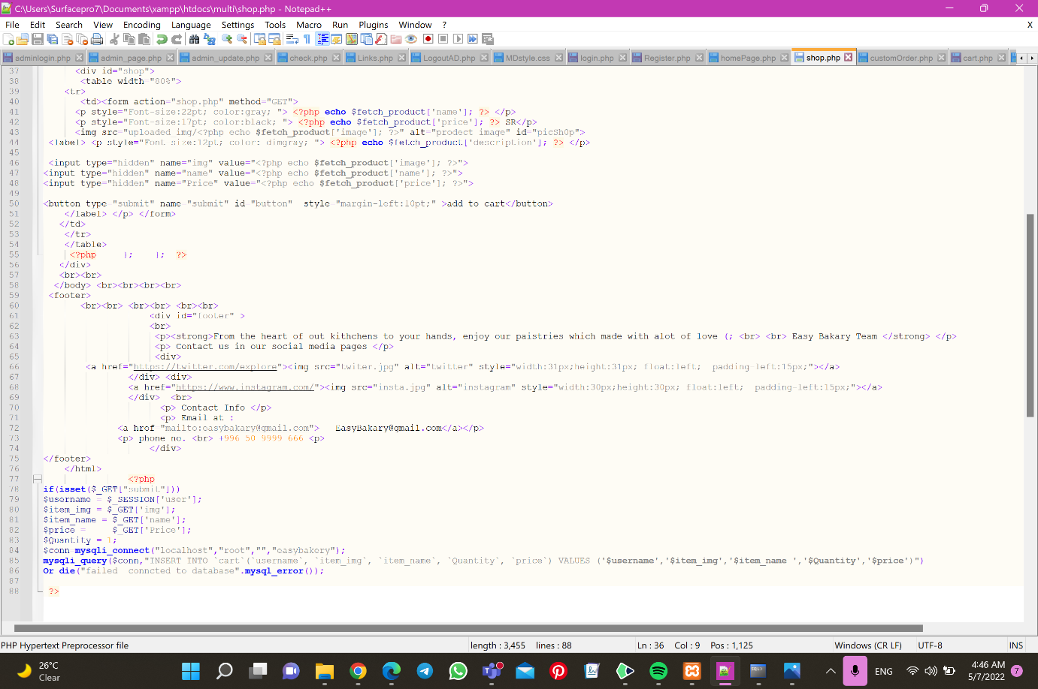

Figure 20-shop2

Custom order:

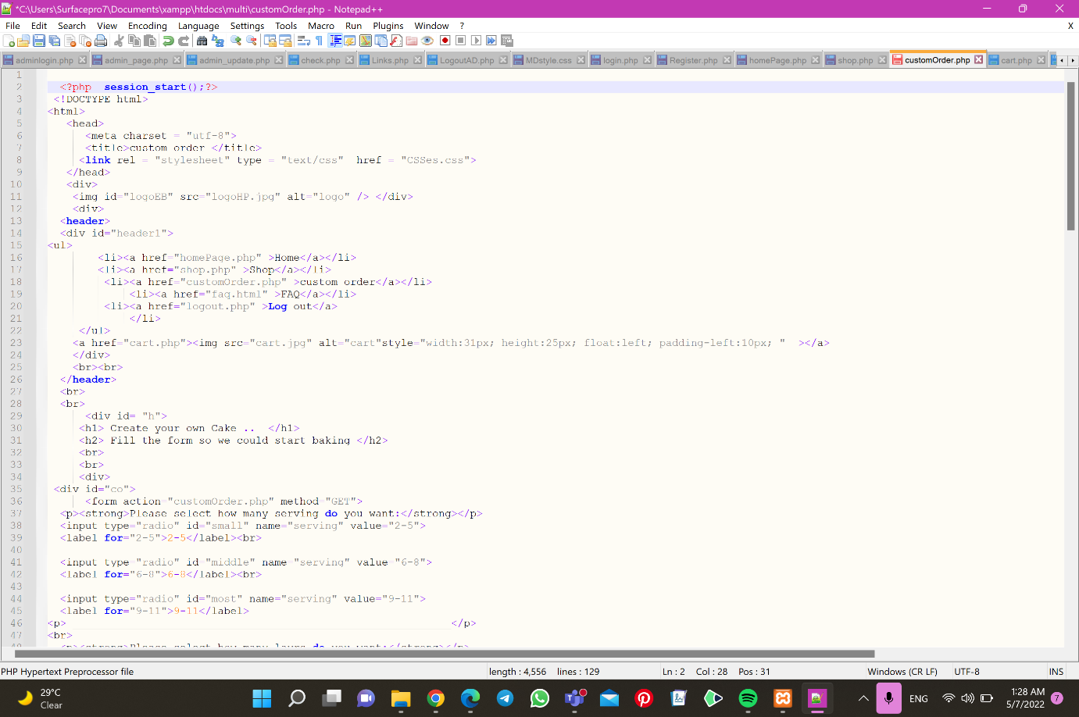

Figure 21- custom order1

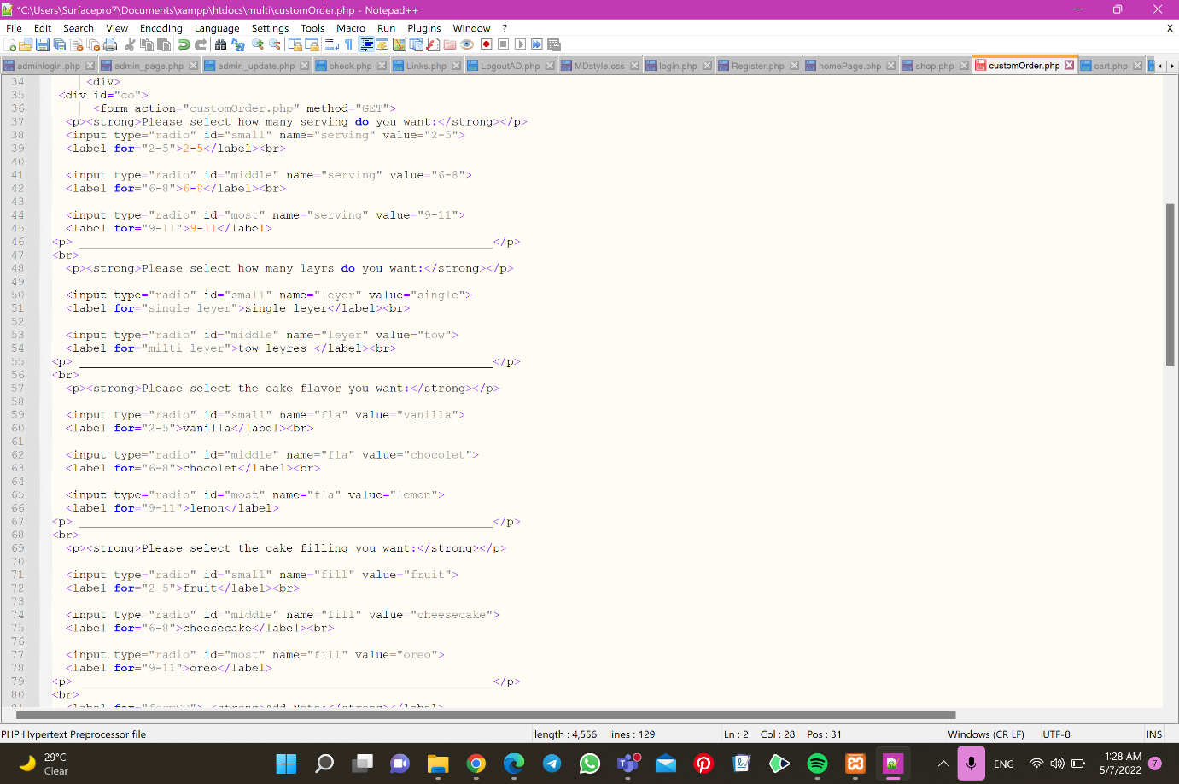

Figure 22- custom order2

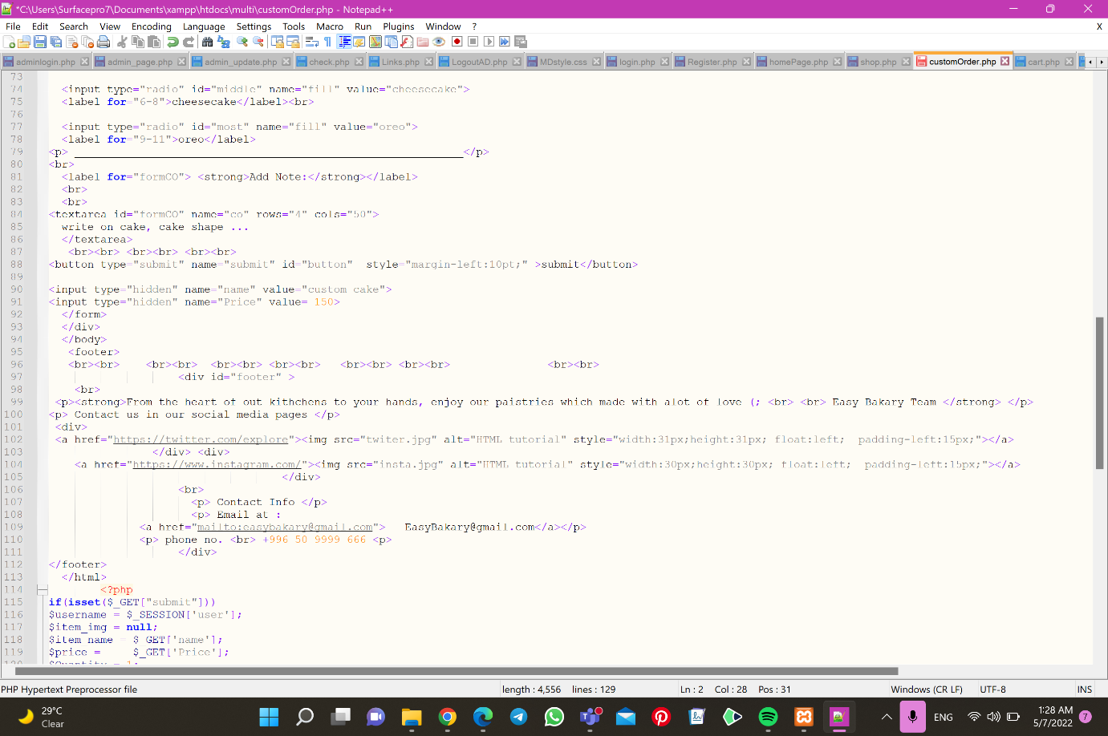

Figure 23- custom order3

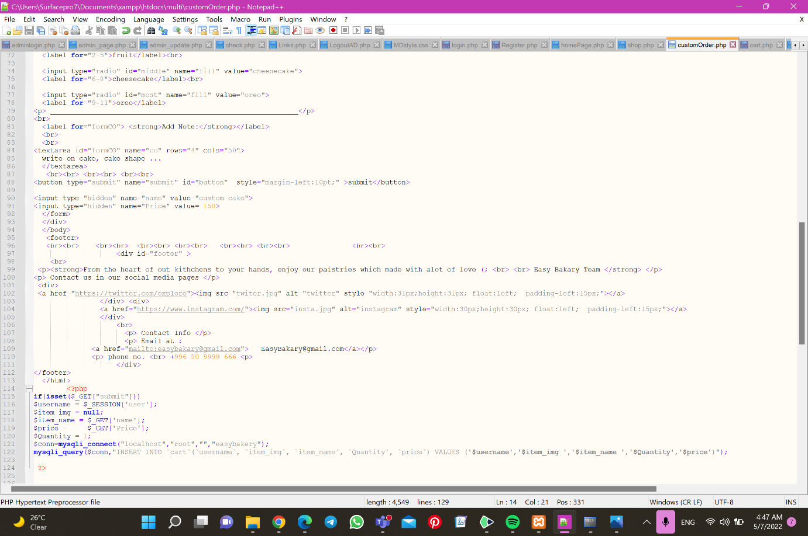

Figure 24- custom order4

Cart:

Figure 25-cart1

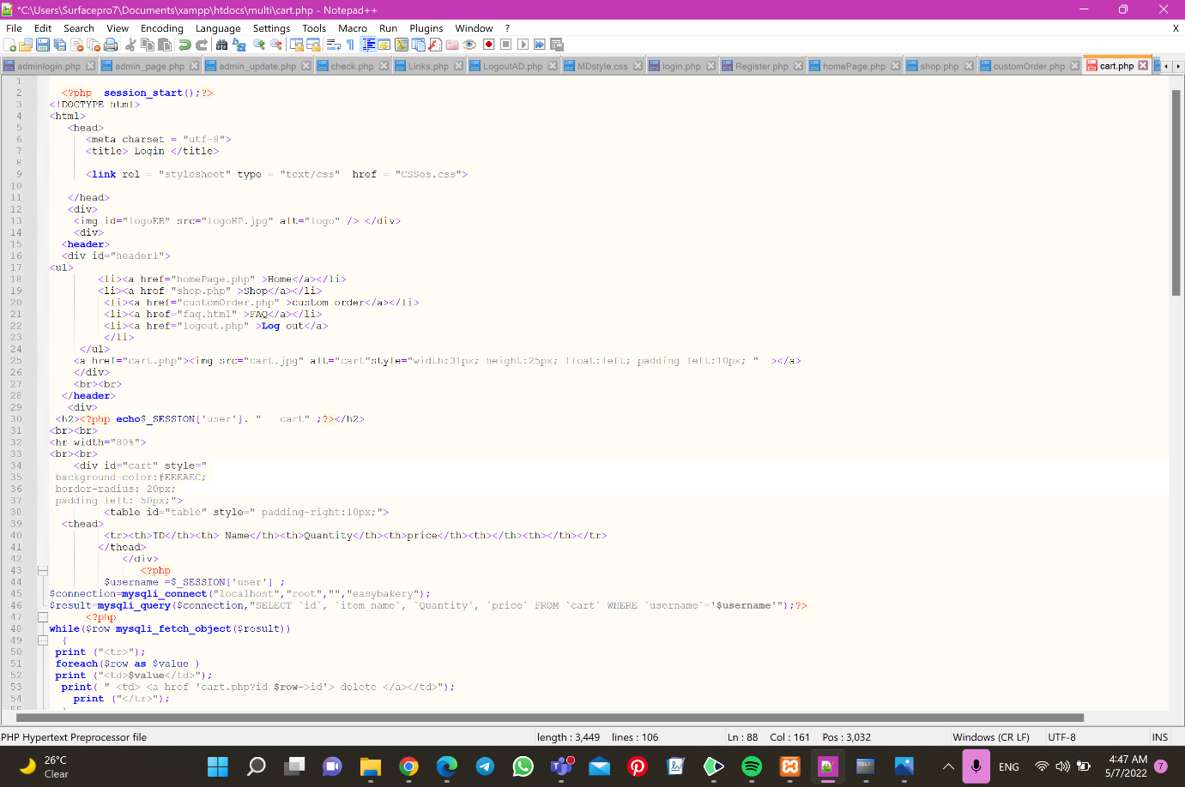

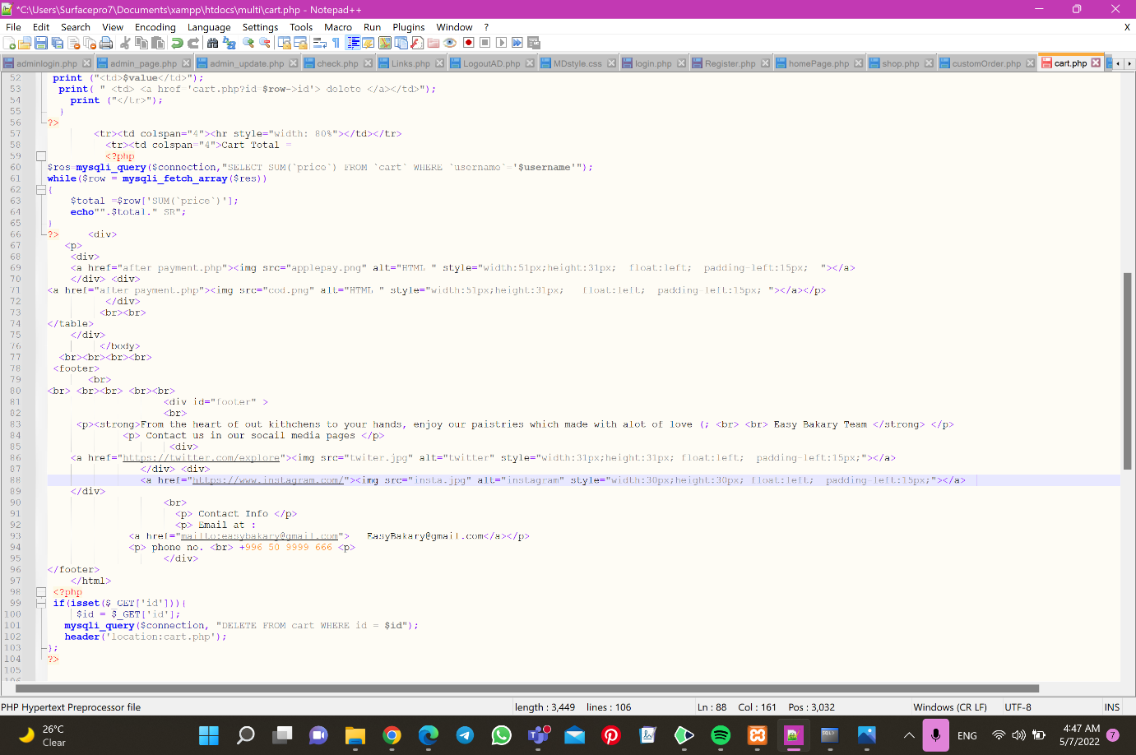

Figure 26-cart2

User logout:

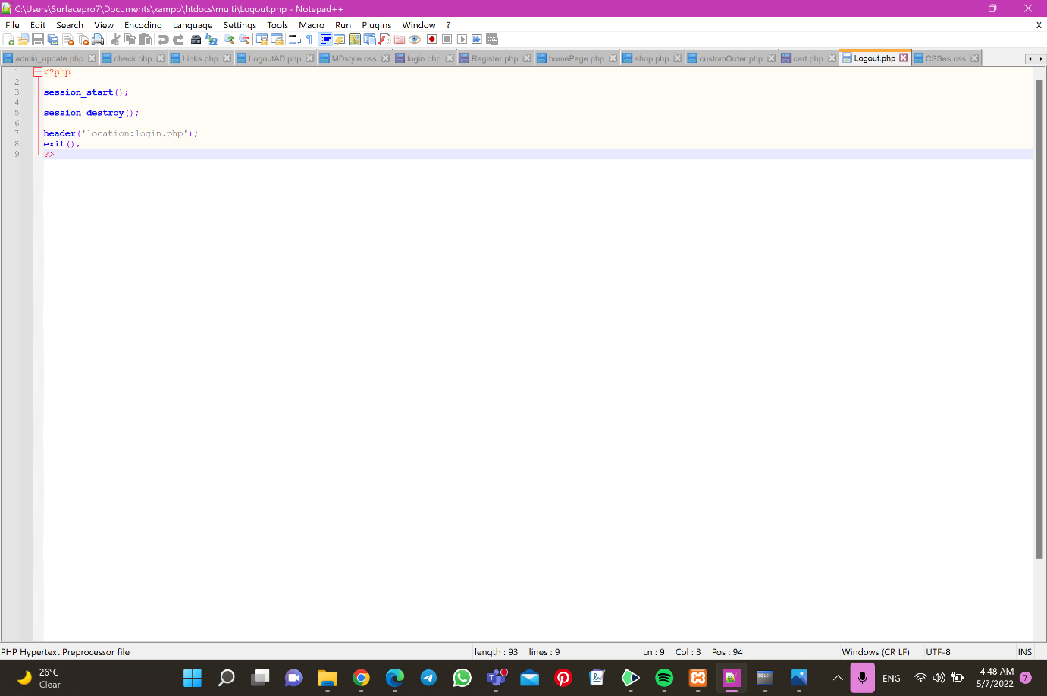

Figure 27- user logout

CSS:

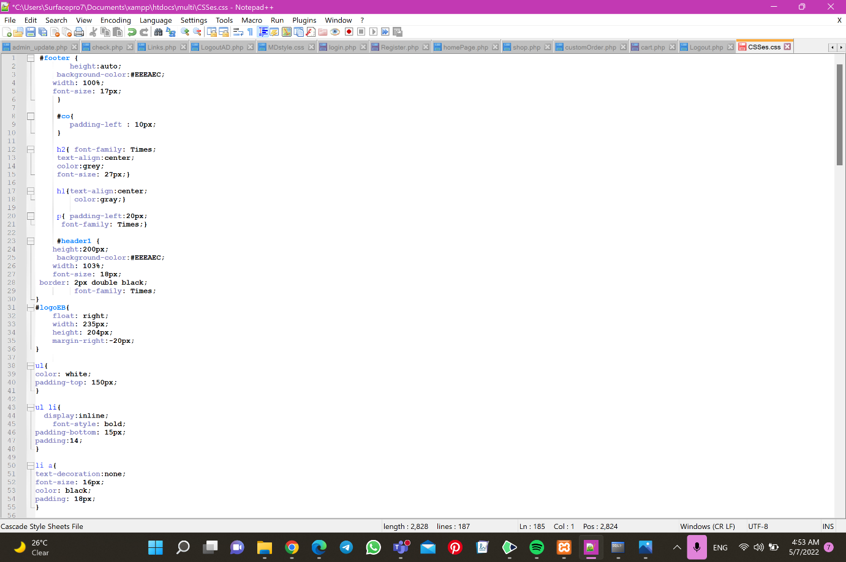

Figure 28- CSS1

Figure 29-CSS2

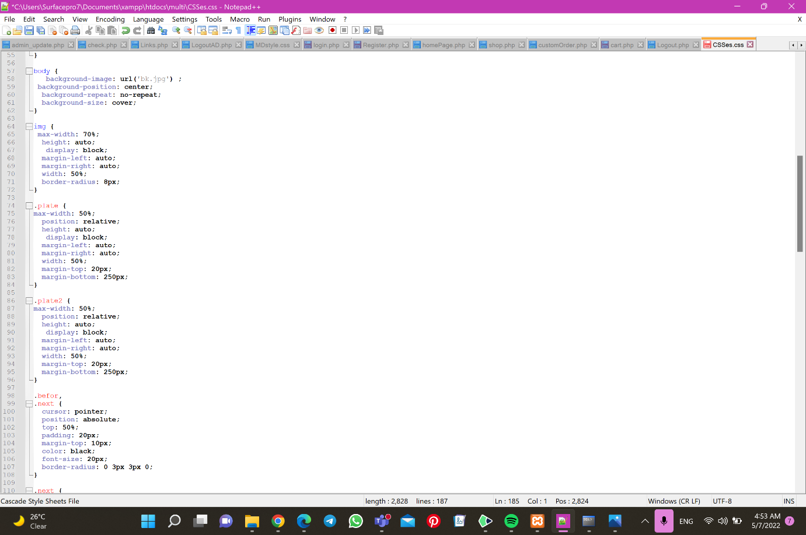

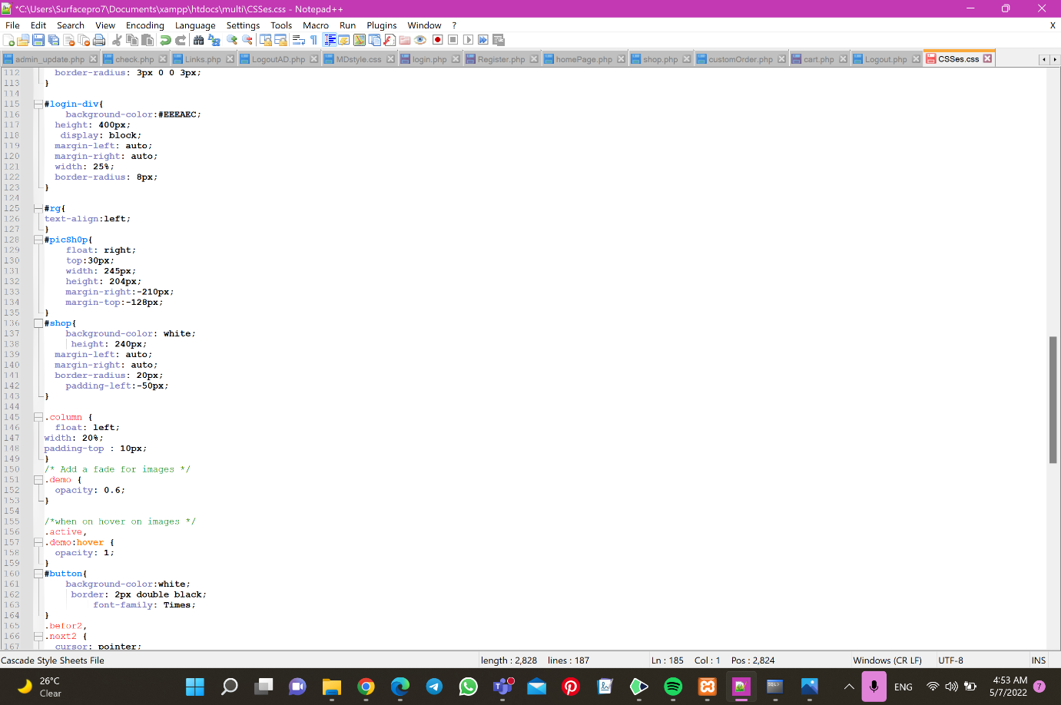

Figure 30-CSS3

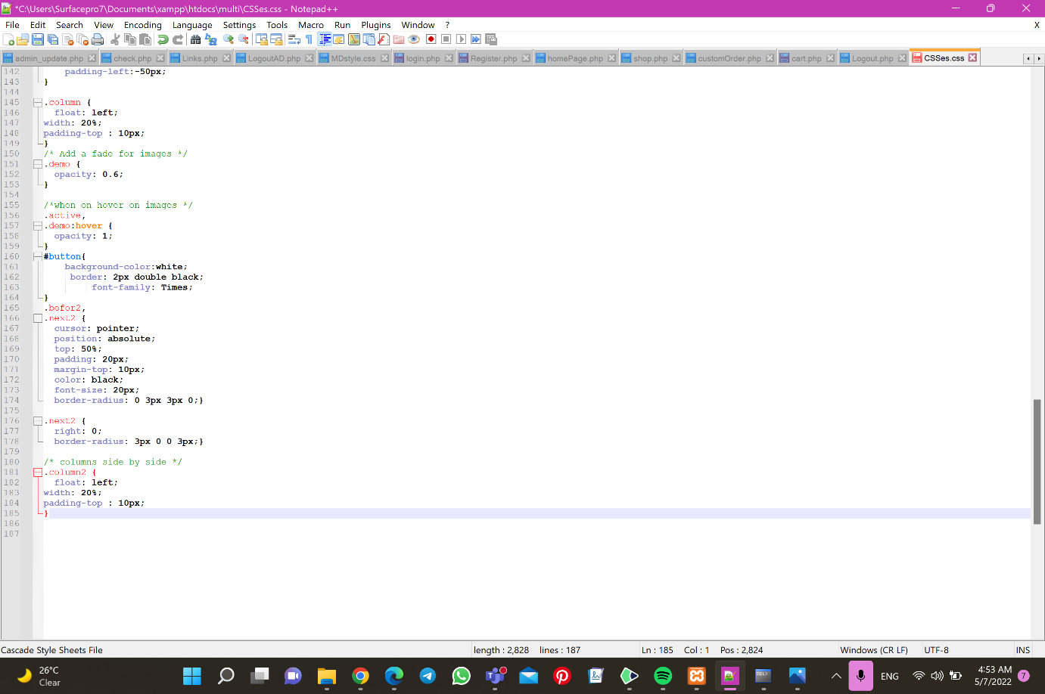

Figure 31-CSS4

**Print screen of database table from PhpMyAdmin:**

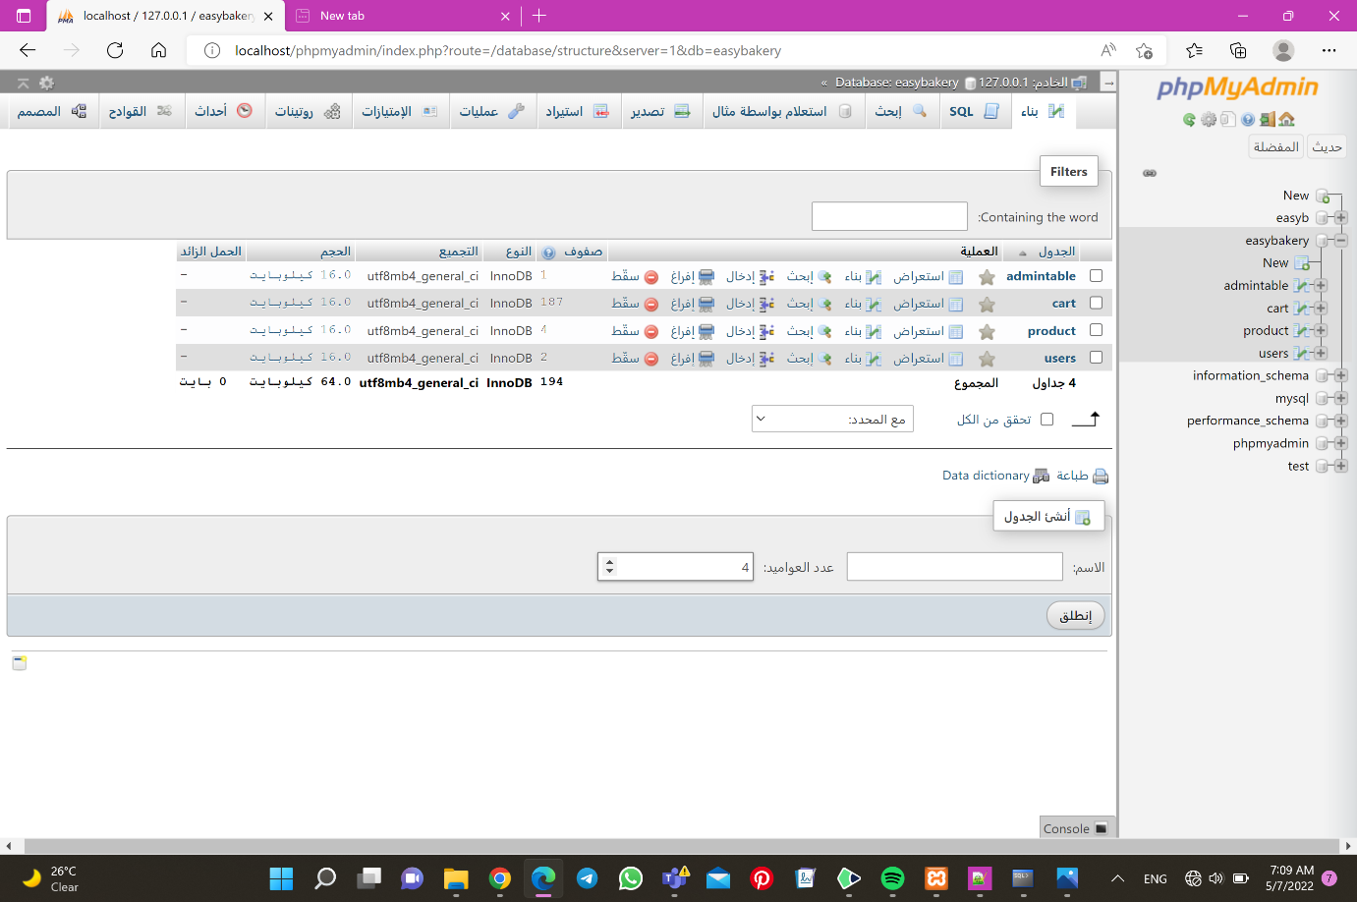

Figure 32-System database

Figure 33-Admin table

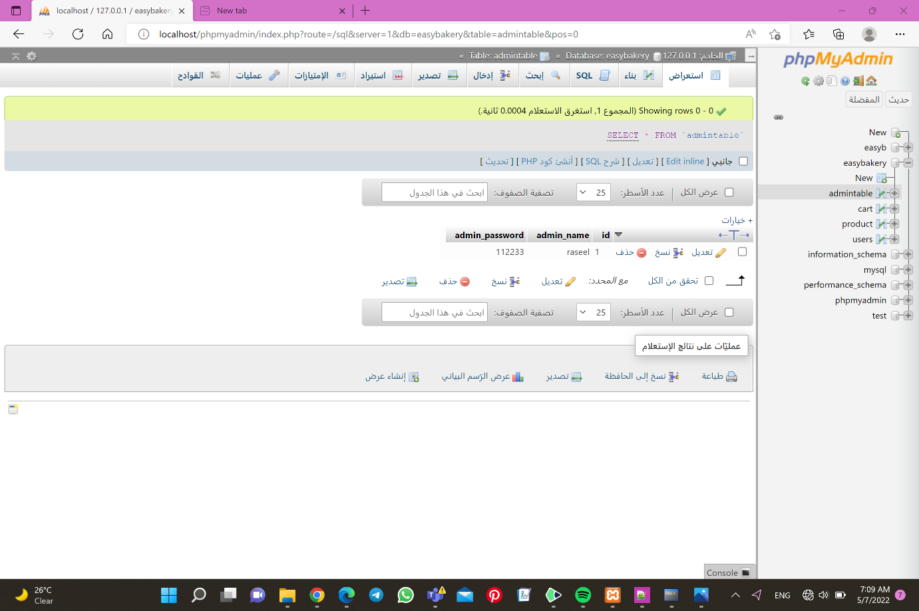

Figure 34-cart table

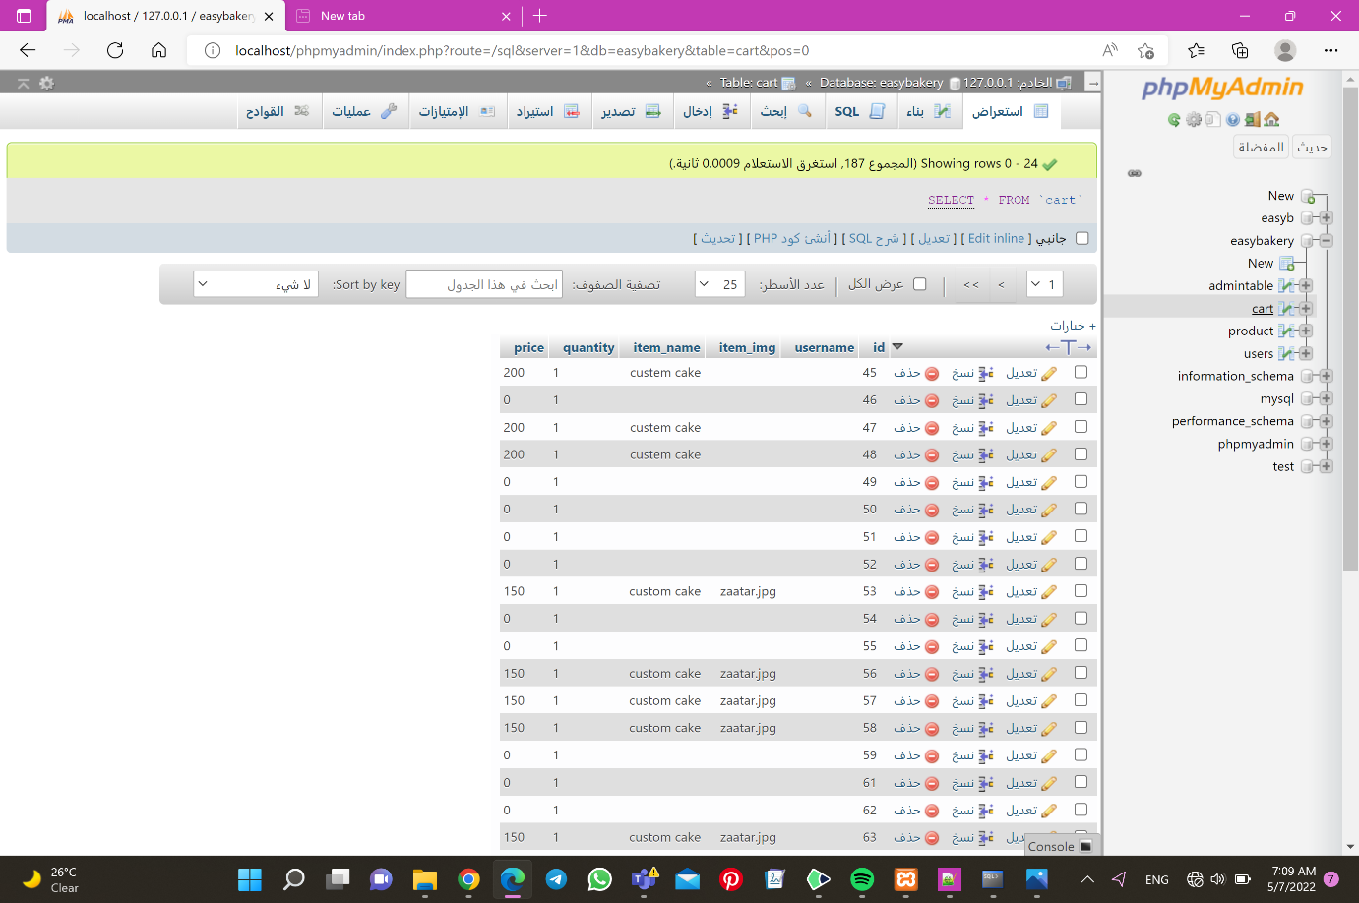

Figure 35-Product table

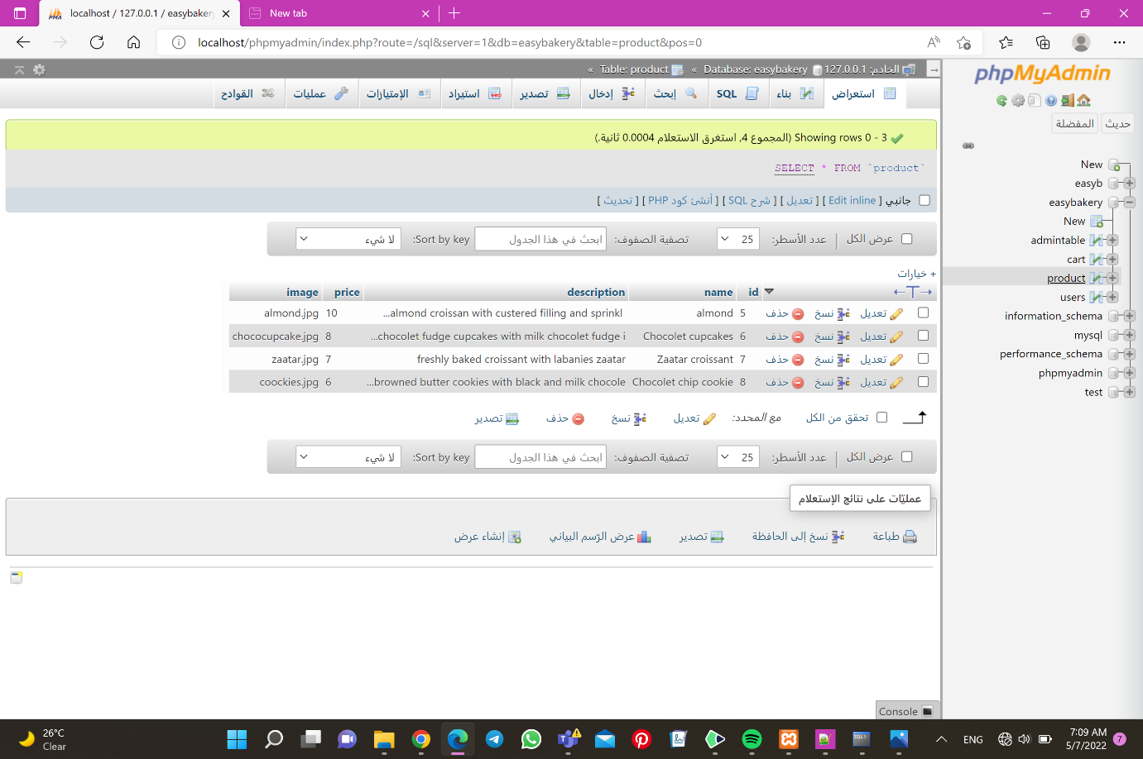

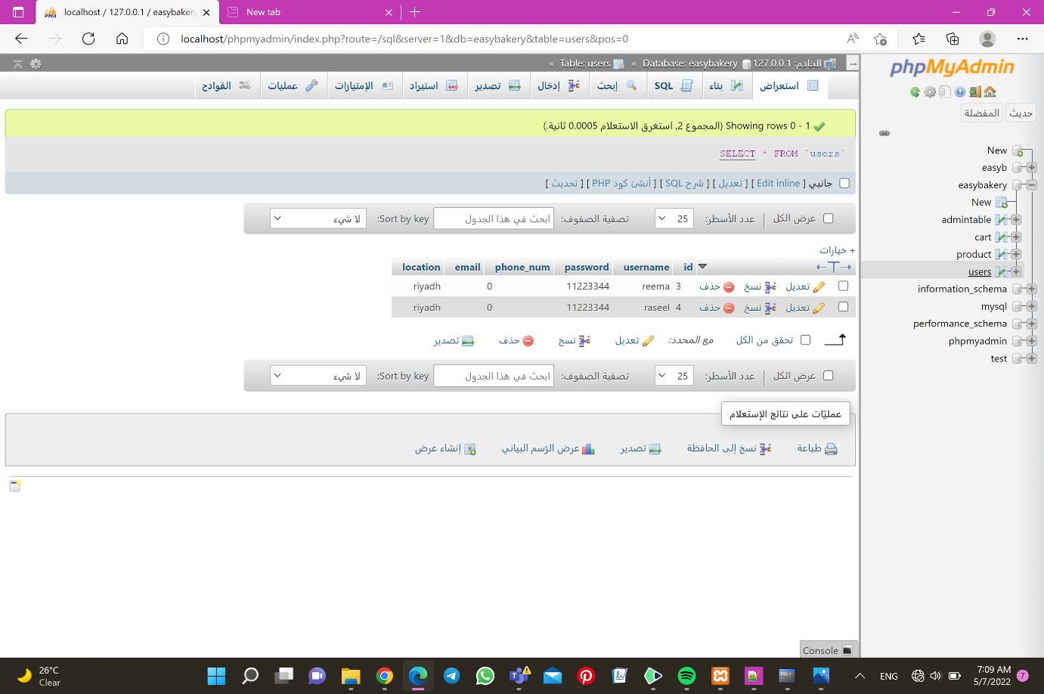

Figure 36-Users table

**Print screen of the user interface:**

Admin side:

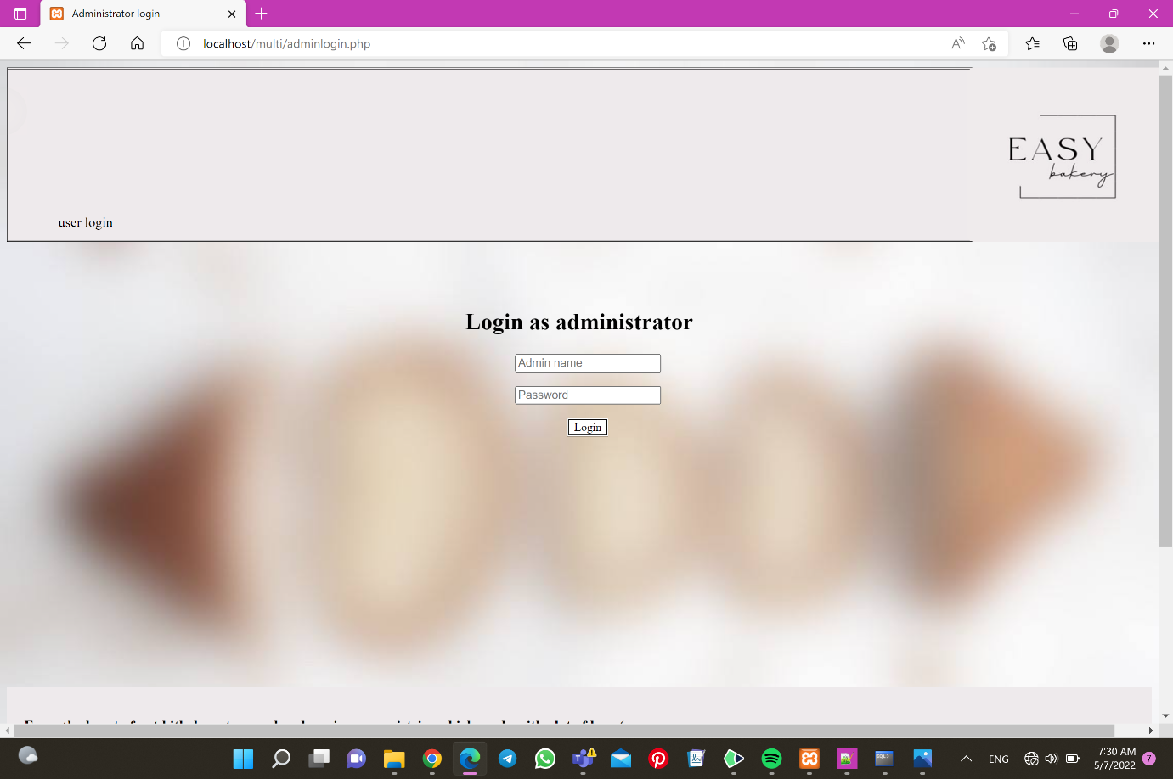

Figure 37- admin login

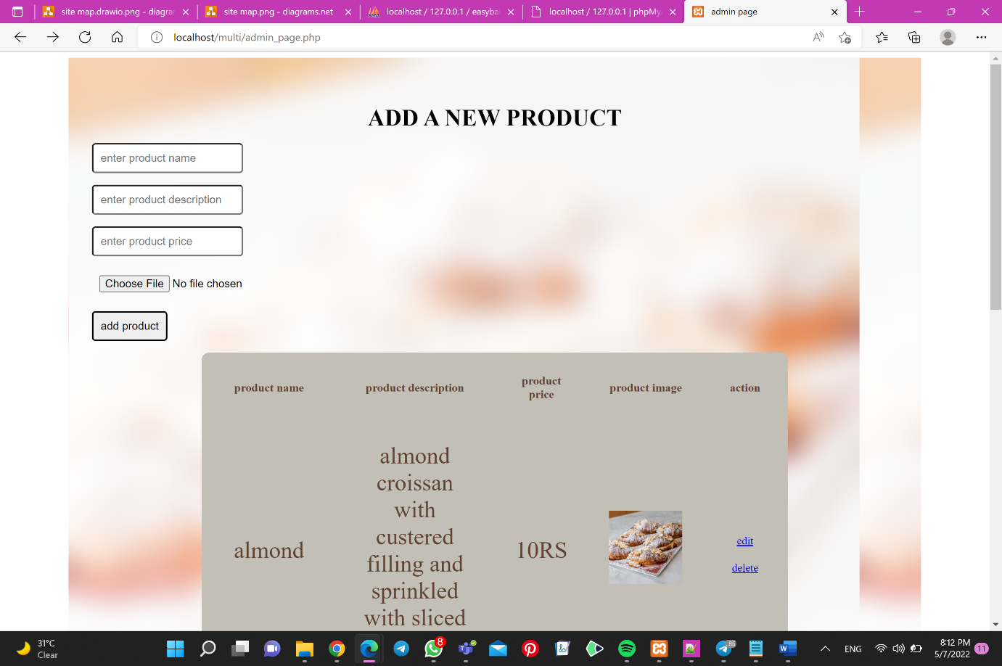

Figure 38- admin page 1

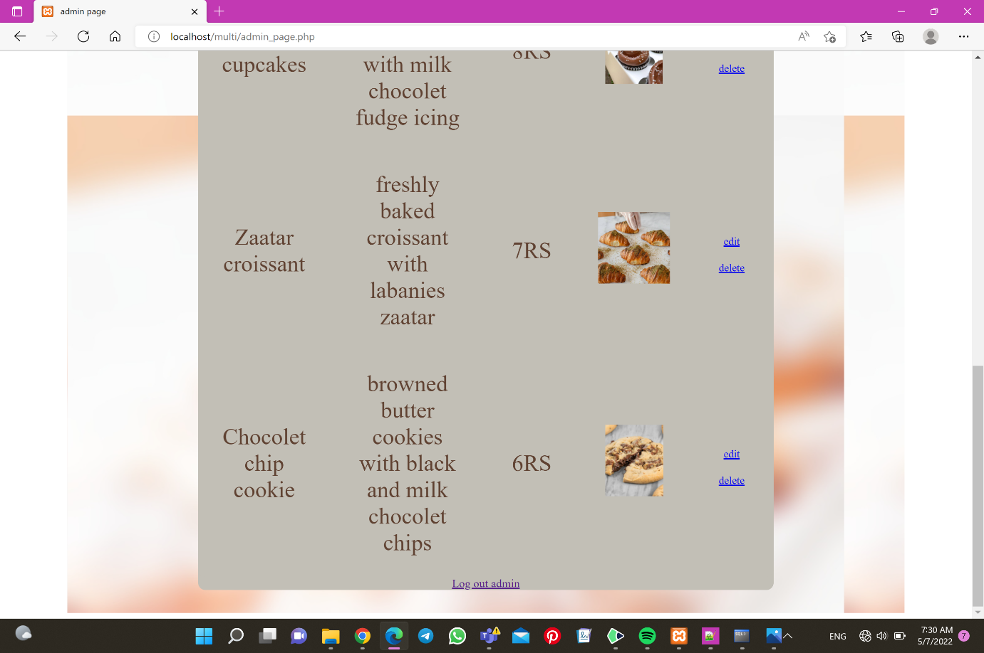

Figure 39- admin page 2

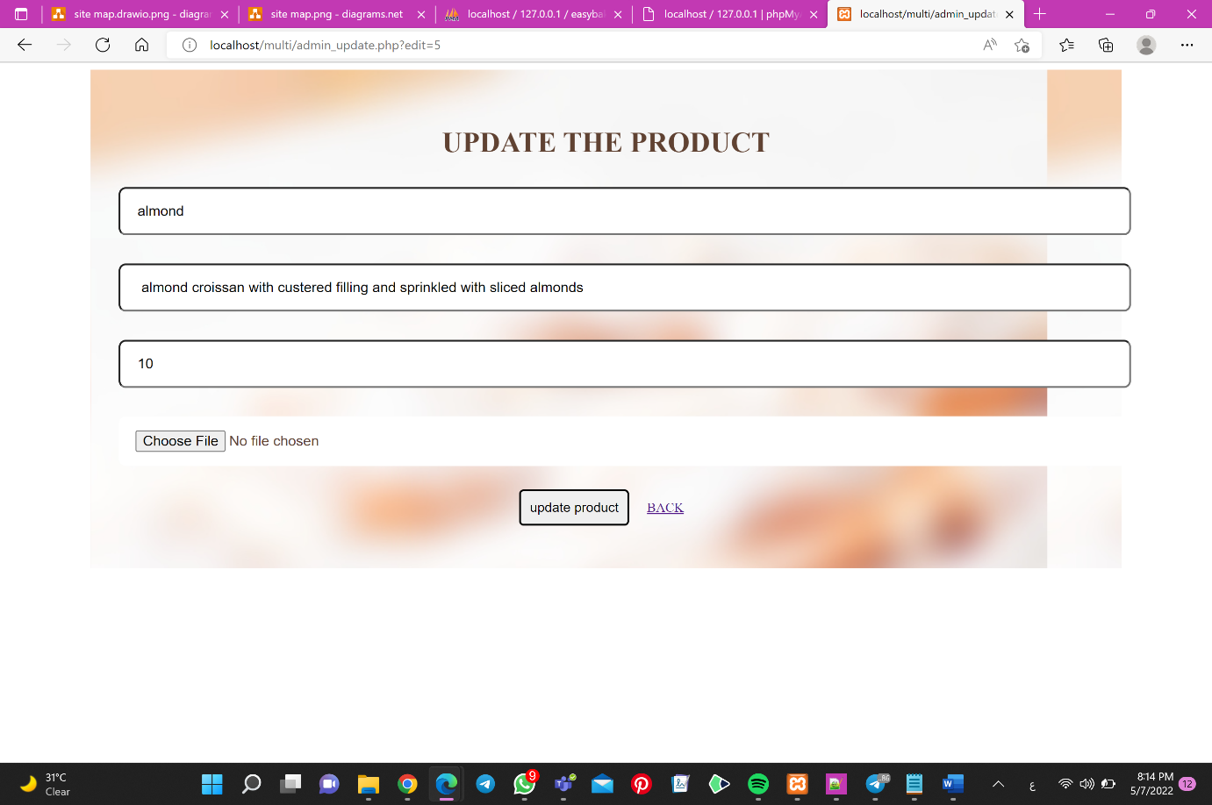

Figure 40- update page

User side:

Figure 41- user login page1

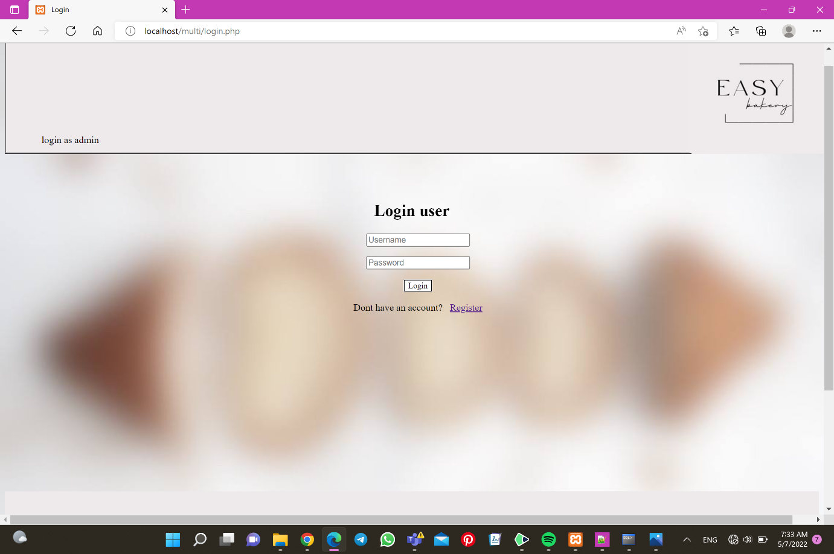

Figure 42- user login page2

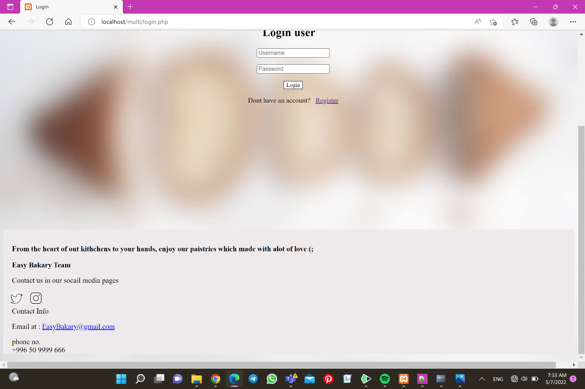

Figure 43- home page 1

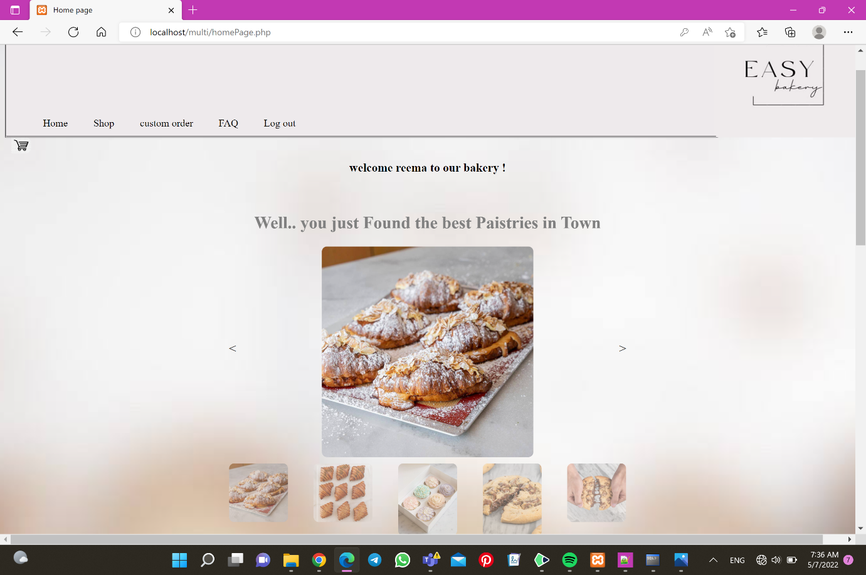

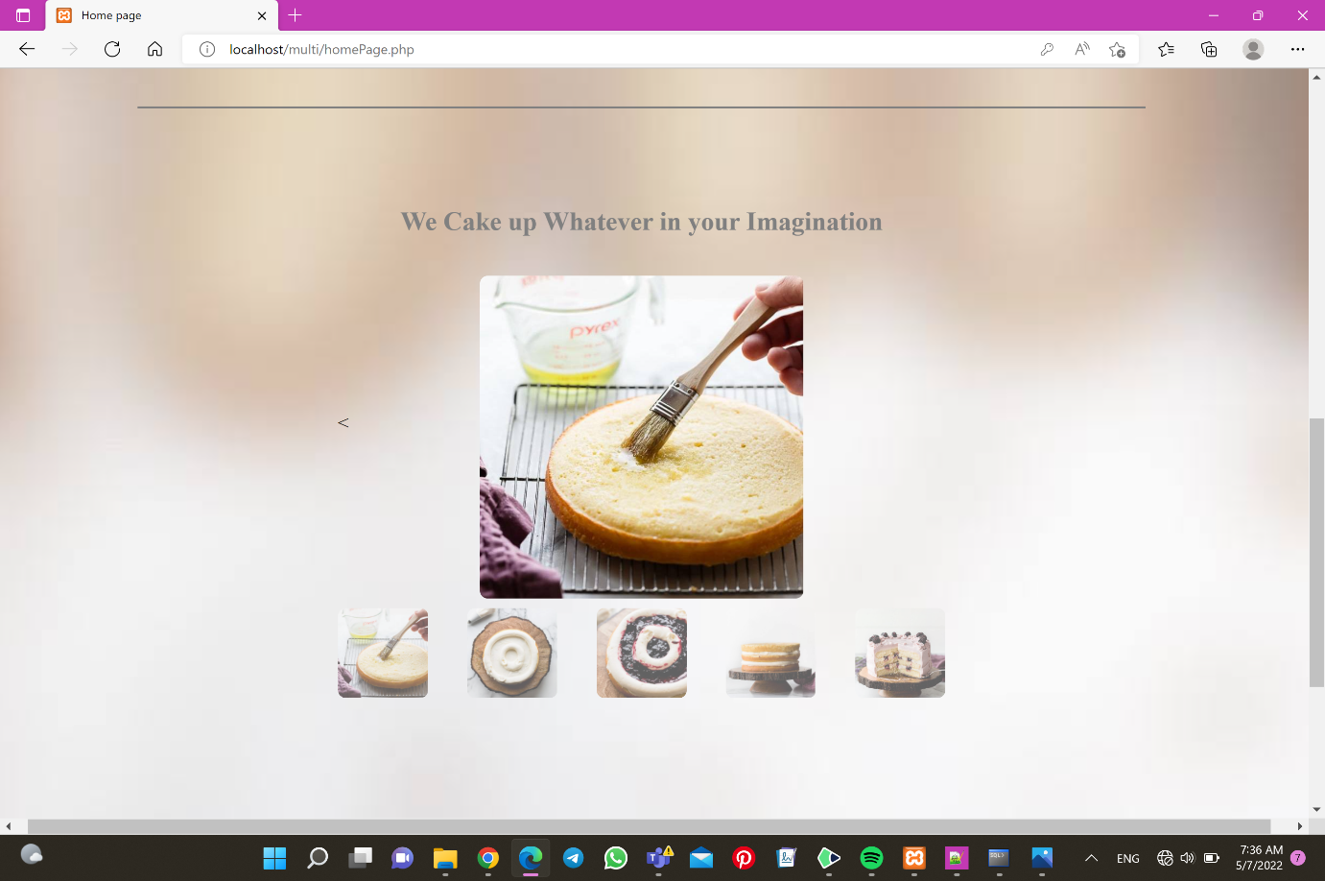Figure 44- home page 2

Figure 45- home page 3

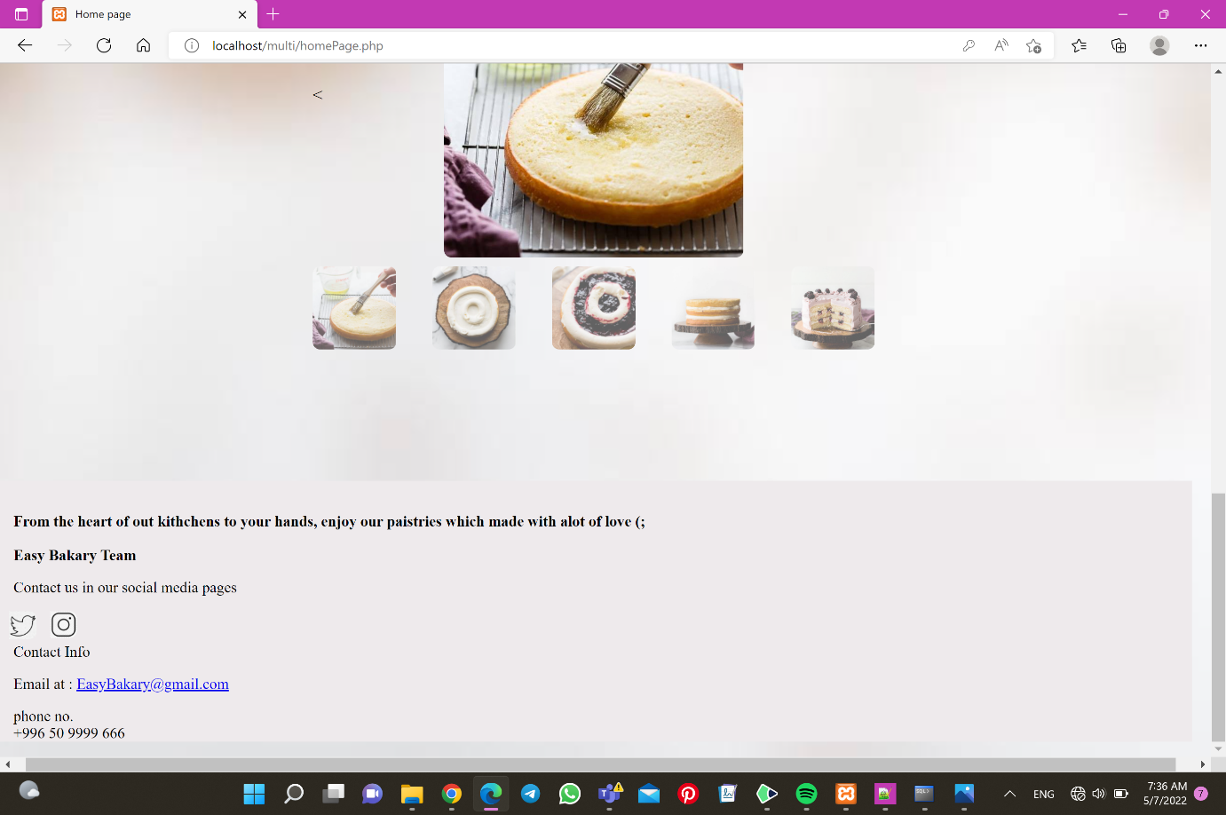

Figure 46- shop1

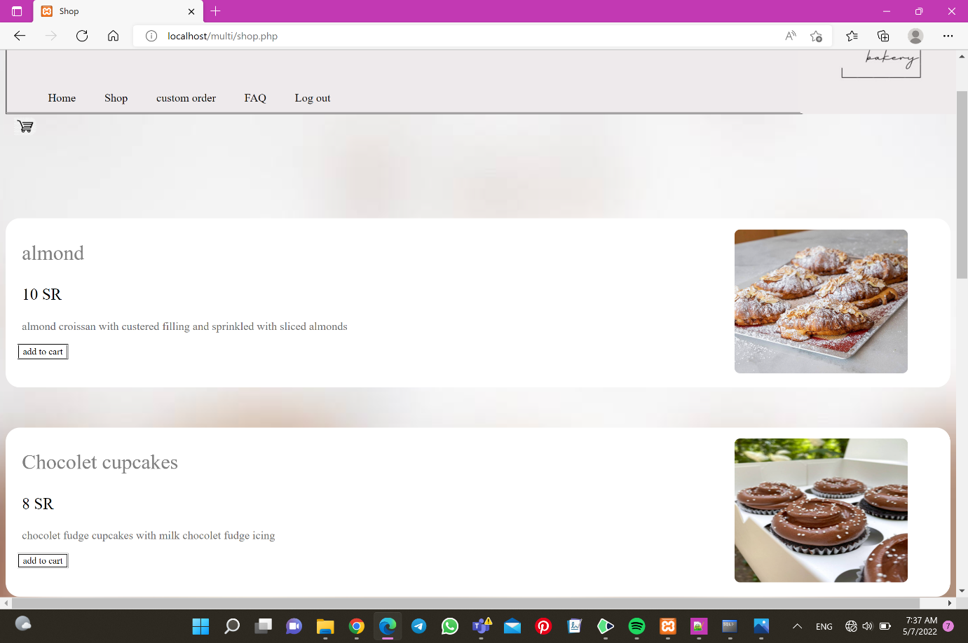

Figure 47-shop2

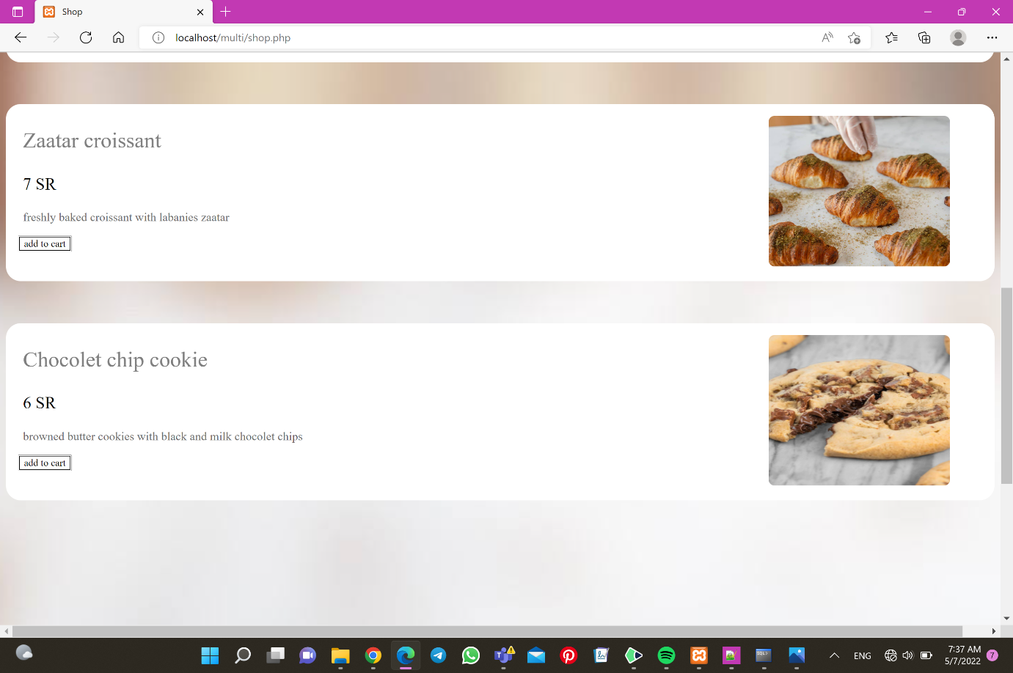

Figure 48-shop3

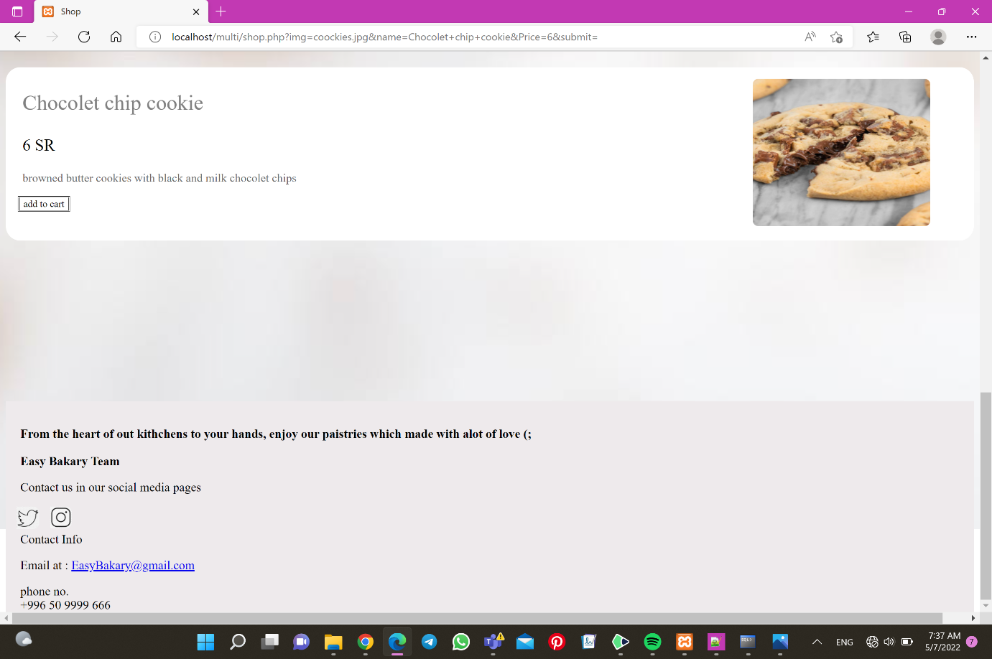

Figure 49 - custom order1

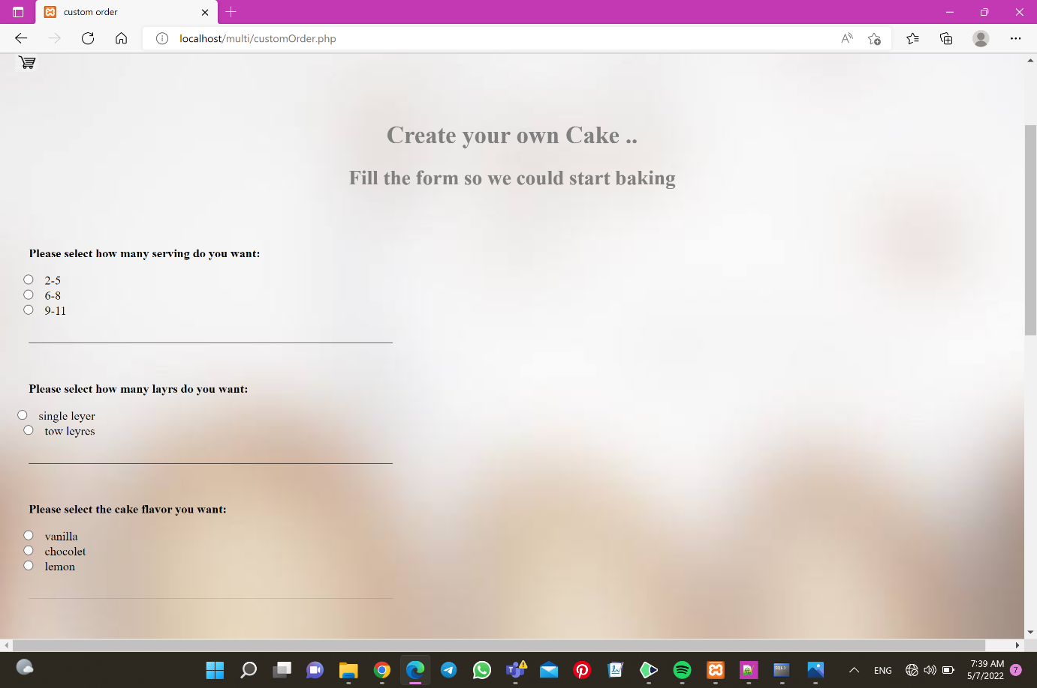

Figure 50- custom order2

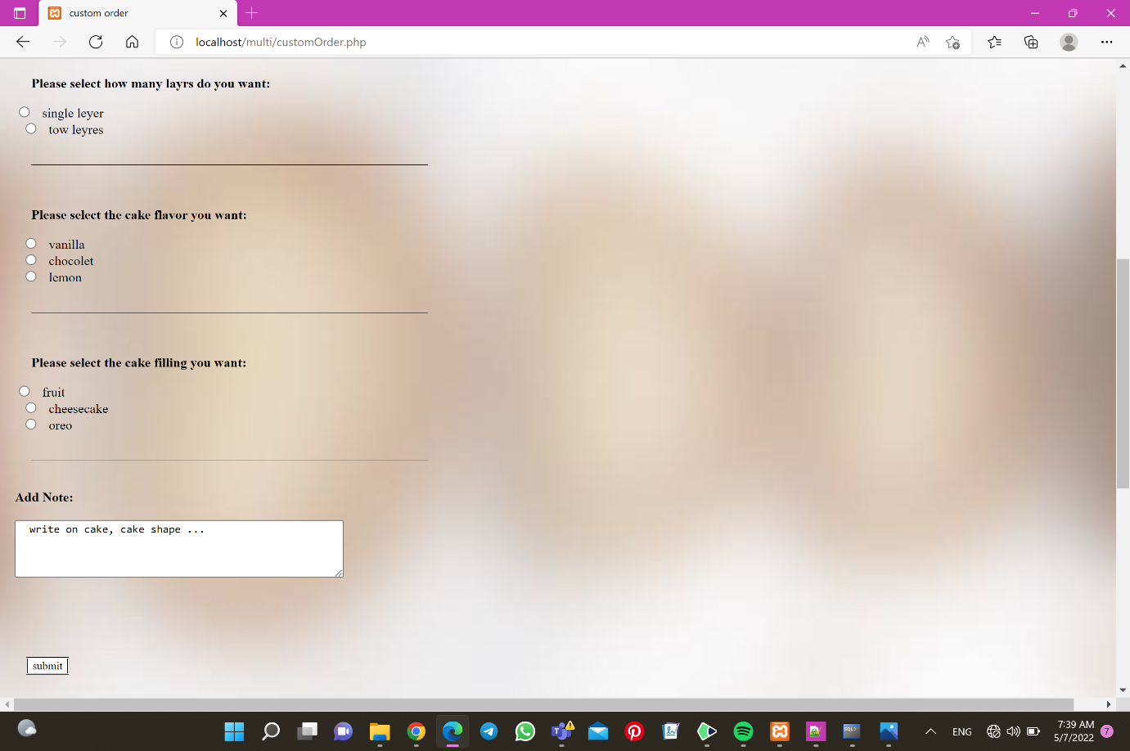

Figure 51- FAQ1

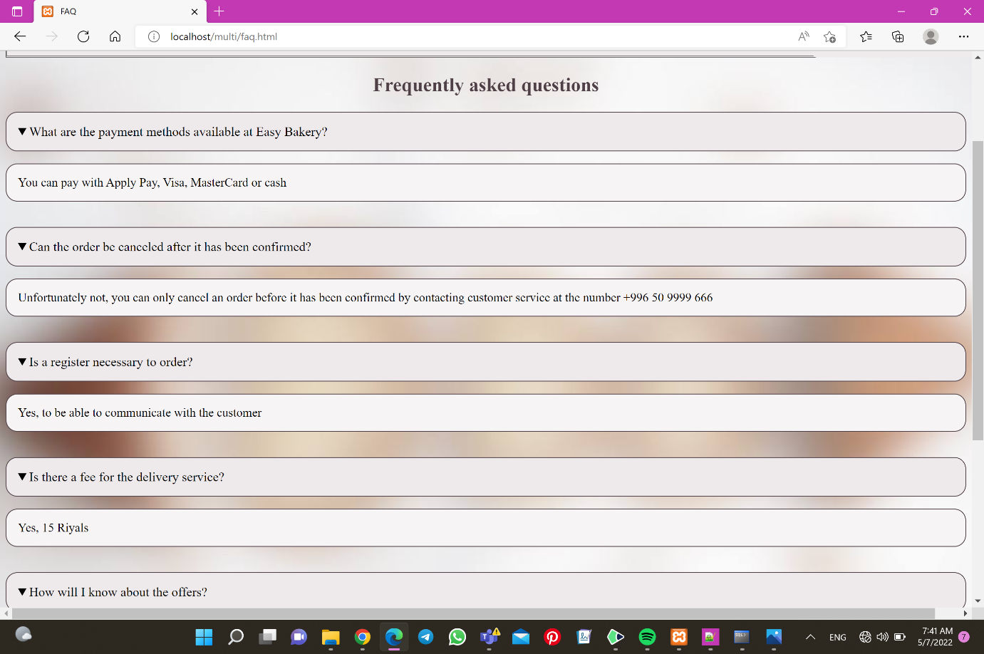

Figure 52 - FAQ2

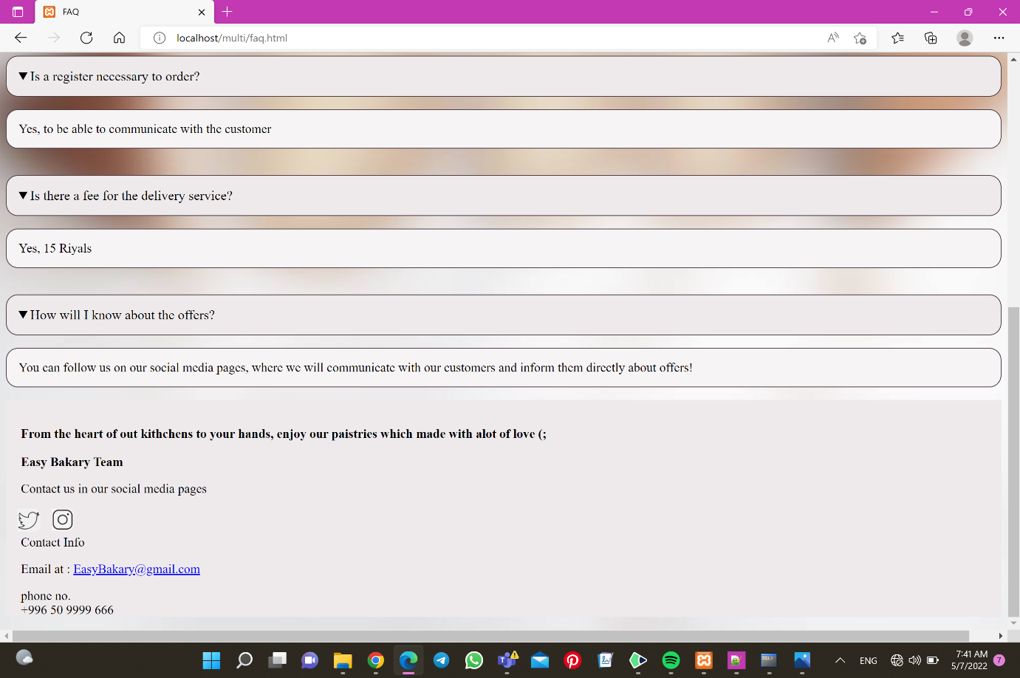

Figure 53- shopping cart

